# Results

## Data collection and sources

The results of papers I-VI are summarized in their respective sub-chapters. Because data was collected over a four year period from 2013-2017, and the papers that form this thesis were written and published at different times, the study period and population described in each paper varies slightly. They differ however only marginally from the final data summary described below.

When data from all registries is taken together, individual level information was available for 375,383 Icelandic citizens, of which 183,544 were female and 181,316 were male. Gender was unknown for 10,523 individuals. The full date of birth was known for 366,188 and birth-year available for the rest. The median birth-year for the whole study population was 1979 (IQR 1958-1997). Death was registered for 12,308 individuals during the study period.

Several papers examined the data, stratified by birth-cohort. The number of children in each birth-cohort who contributed data to the present study are shown in Table 9.

Table 9 Demographic information regarding birth-cohorts used in the study

|  |  |  |  |
| --- | --- | --- | --- |
| Birth-cohort | No. children | Proportion male (%) | No. moved |
| 2005 | 4,803 | 51.5 | 578 |
| 2006 | 4,887 | 51.4 | 572 |
| 2007 | 4,993 | 51.6 | 567 |
| 2008 | 5,153 | 51.7 | 571 |
| 2009 | 5,331 | 51.7 | 553 |
| 2010 | 5,203 | 51.4 | 525 |
| 2011 | 4,849 | 51.7 | 473 |
| 2012 | 4,841 | 51.2 | 430 |
| 2013 | 4,566 | 49.4 | 344 |
| 2014 | 4,527 | 51.1 | 223 |
| 2015 | 4,198 | 51.3 | 144 |
| 2016 | 4,112 | 50.7 | 26 |

### Statistics Iceland

Statistics Iceland provided data on the immigration and emigration of all Icelandic children zero to four years of age from 2005-2017. Of the 57,695 Icelandic children born 2005 or later, 5,577 moved to or from the country 6,847 times. The proportion of children in each birth-cohort who moved at least once before five years of age, was consistently 9%-12% of those birth-cohorts who had full follow-up time (birth-cohorts 2005-2012).

### Landspitali University Hospital patient registry

All visits and hospitalizations with ICD-10 diagnostic codes compatible with respiratory infections (Table 3) and procedural codes compatible with tympanostomy tube procedures (Table 4), were extracted from Landspitali’s patient registry. The number of visits and hospitalizations corresponding to each of the study’s ICD-10 codes recorded as initial diagnosis, are shown in Table 10.

Table 10 Number of visits or hospitalizations with International Classification of Diseases, 10th revision codes used in the current study as the primary diagnosis

|  |  |  |  |  |
| --- | --- | --- | --- | --- |
| ICD-10 code | Disease | Hospital visits | Hospitalizations | Primary care visits |
| A40 | Streptococcal sepsis | 37 | 135 | 68 |
| A41 | Other sepsis | 370 | 777 | 279 |
| A48 | Other bacterial diseases, not elsewhere classified | 5 | 28 | 10 |
| A49 | Bacterial infection of unspecified site | 123 | 26 | 1,861 |
| B00 | Herpesviral [herpes simplex] infections | 497 | 22 | 2,176 |
| B08 | Other viral infections characterized by skin and mucous membrane lesions, not elsewhere classified | 76 | 1 | 655 |
| B33 | Other viral diseases, not elsewhere classified | 32 | 4 | 106 |
| B34 | Viral infection of unspecified site | 25,601 | 528 | 329,179 |
| B95 | Streptococcus, Staphylococcus, and Enterococcus as the cause of diseases classified elsewhere | 12 | 4 | 40 |
| B96 | Other bacterial agents as the cause of diseases classified elsewhere | 5 | 7 | 29 |
| G00 | Bacterial meningitis,not elsewhere classified | 79 | 60 | 3 |
| H65 | Nonsuppurative otitis media | 2,803 | 75 | 38,585 |
| H66 | Suppurative and unspecified otitis media | 11,647 | 244 | 160,086 |
| H70 | Mastoiditis and related conditions | 164 | 86 | 259 |
| H72 | Perforation of tympanic membrane | 1,270 | 233 | 1,947 |
| H73 | Other disorders of tympanic membrane | 67 | 3 | 727 |
| J00 | Acute nasopharyngitis [common cold] | 3,525 | 49 | 124,984 |
| J01 | Acute sinusitis | 4,625 | 113 | 152,076 |
| J02 | Acute pharyngitis | 1,869 | 44 | 124,874 |
| J03 | Acute tonsillitis | 5,019 | 213 | 106,491 |
| J04 | Acute laryngitis and tracheitis | 983 | 38 | 19,288 |
| J05 | Acute obstructive laryngitis [croup] and epiglottitis | 2,738 | 40 | 3,148 |
| J06 | Acute upper respiratory infections of multiple and unspecified sites | 3,649 | 94 | 110,236 |
| J09 | Influenza due to certain identified influenza viruses | 250 | 185 | 9 |
| J10 | Influenza due to other identified influenza virus | 282 | 151 | 699 |
| J11 | Influenza due to unidentified influenza virus | 1,003 | 77 | 34,949 |
| J12 | Viral pneumonia, not elsewhere classified | 206 | 189 | 189 |
| J13 | Pneumonia due to Streptococcus pneumoniae | 129 | 265 | 80 |
| J14 | Pneumonia due to Hemophilus influenzae | 18 | 44 | 34 |
| J15 | Bacterial pneumonia, not elsewhere classified | 2,489 | 1,129 | 1,870 |
| J16 | Pneumonia due to other infectious organisms, not elsewhere classified | 60 | 37 | 62 |
| J17 | Pneumonia in diseases classified elsewhere | 17 | 15 | 38 |
| J18 | Pneumonia, unspecified organism | 8,576 | 4,501 | 66,232 |
| J20 | Acute bronchitis | 2,431 | 297 | 148,963 |
| J21 | Acute bronchiolitis | 2,874 | 707 | 6,178 |
| J22 | Unspecified acute lower respiratory infection | 356 | 55 | 9,425 |
| J32 | Chronic sinusitis | 3,298 | 405 | 52,899 |
| J36 | Peritonsillar abscess | 1,095 | 254 | 1,239 |
| J40 | Bronchitis, not specified as acute or chronic | 893 | 49 | 77,272 |
| J85 | Abscess of lung and mediastinum | 98 | 41 | 24 |
| J86 | Pyothorax | 20 | 62 | 48 |
| J90 | Pleural effusion, not elsewhere classified | 560 | 409 | 599 |
| N30 | Cystitis | 6,112 | 568 | 133,560 |
| N39 | Other disorders of urinary system | 12,901 | 2,868 | 36,154 |
| R05 | Cough | 2,471 | 11 | 83,948 |
| R50 | Fever of other and unknown origin | 3,433 | 557 | 27,121 |

A total of 169,585 records (of 74,740 individuals) were available, of which 135,841 (64,090) were visits to outpatient clinics or emergency departments and 33,744 (20,318) were hospital admissions. The most visits of a single individual was 170 and the most admissions, 31. The number of procedures performed at Landspitali University Hospital for this study is shown in Table 11.

Table 11 Number of study NOMESCO Classification of Surgical Procedures performed in the current study

|  |  |  |
| --- | --- | --- |
| NCSP code | Description | Number of procedures |
| EMSB00 | Excision of lesion of tonsil or adenoid | 1 |
| EMSB10 | Tonsillectomy | 88 |
| EMSB15 | Intracapsular destruction of tonsils | 2 |
| EMSB20 | Adenotonsillectomy | 101 |
| EMSB30 | Adenotomy | 170 |
| EMSB99 | Other excision on tonsils and adenoids | 2 |
| EMSW99 | Other operation on tonsil or adenoids | 1 |
| DCSA10 | Paracentesis of tympanic membrane | 289 |
| DCSA20 | Insertion of ventilating tube through tympanic membrane | 340 |
| DCSW00 | Removal of ventilating tube from tympanic membrane | 0 |

The age distribution of visits and hospital admissions are shown in Figure 1. Though children and young adults comprise most of the visits due to study diagnoses, older adults make up the largest number of hospitalizations.

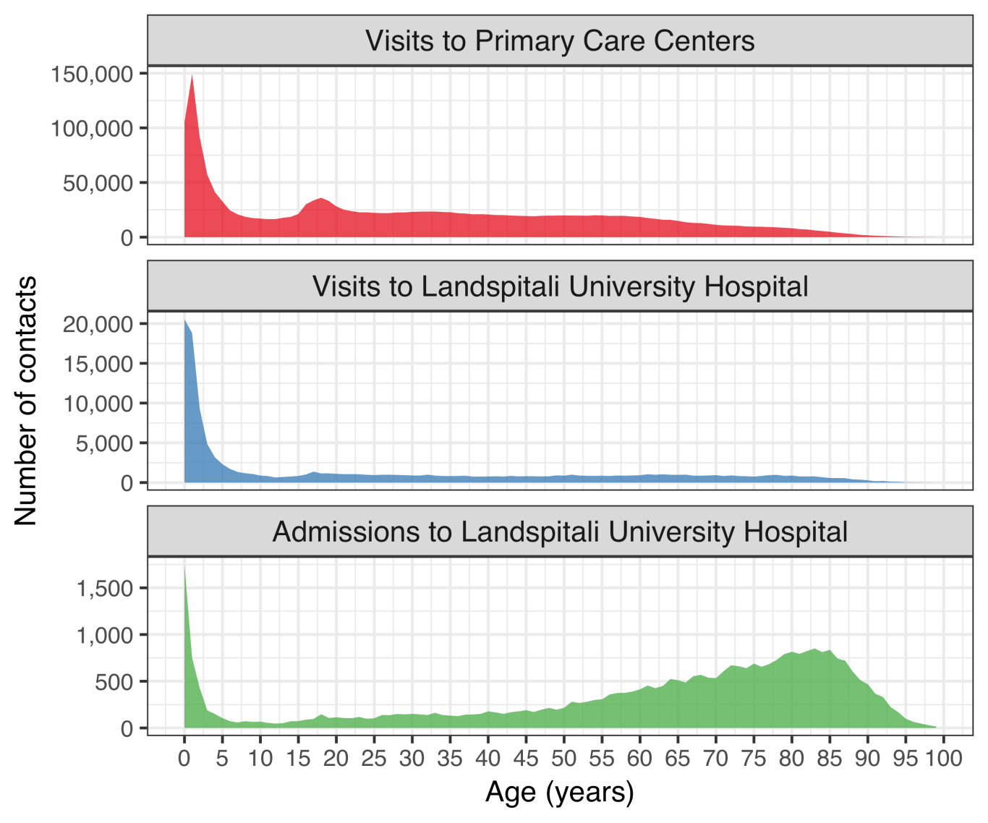

Figure 1 Total number of contacts to Landspitali University Hospital and Primary Care Centers

### The Primary Care Registry

The Primary Care Registry recorded all primary care health contacts for the period 2005-2015. All physician contacts associated with the diagnostic codes listed in Table 3 were extracted for that given period. A total of 1,963,439 separate contacts were recorded between 298,307 individual patients and 1,266 different physicians. The most visits for a single individual was 212. The distribution of contacts by age can be seen in Figure 1.

### The National Vaccine Registry

The National Vaccine Registry recorded all administered vaccine doses for the period 2005-2017. All recorded pneumococcal vaccine doses were extracted. A total of 110,712 doses of pneumococcal vaccines were administered to 51,601 individuals during the study period. The monthly number of administered doses per age-group and vaccine is shown in Figure 2.

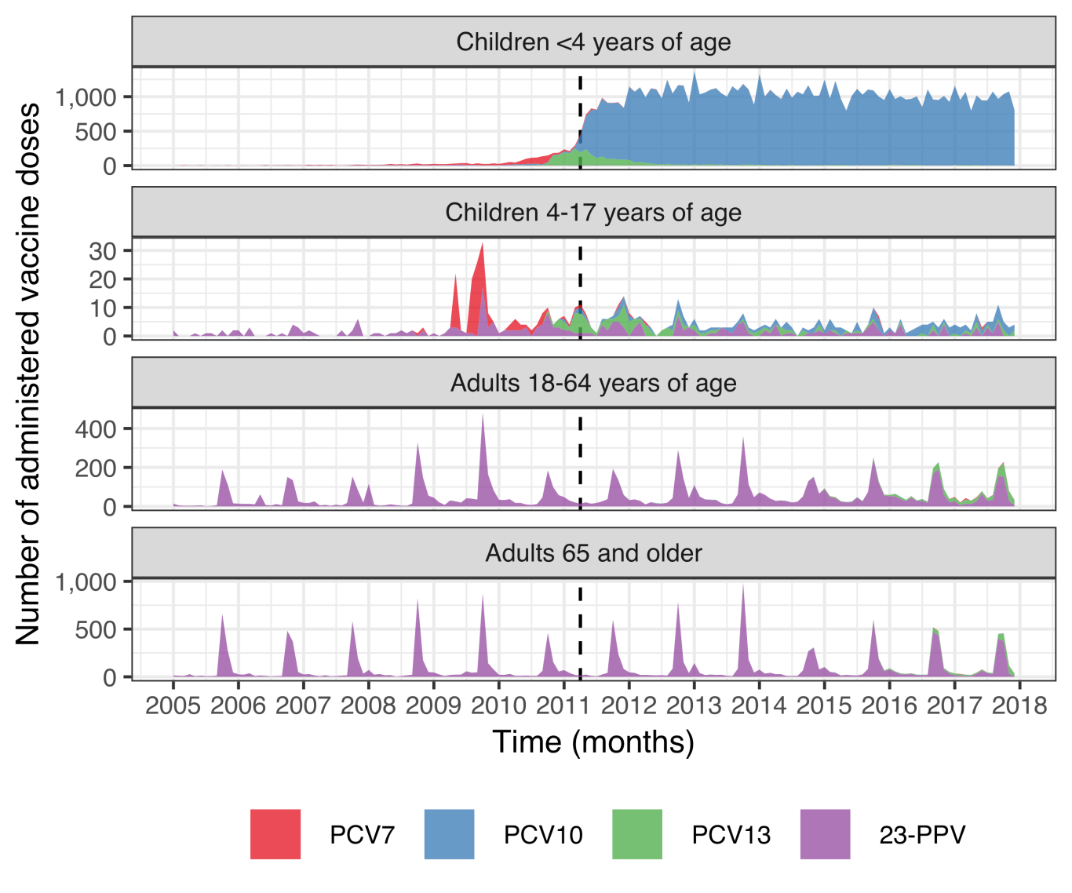

Figure 2 Monthly number of administered pneumococcal vaccine doses by type and age-group

Table 12 shows the number of children in each birth-cohort who had received zero, one, two, or three doses of a pneumococcal conjugate vaccine by four years of age. Children who moved to or from the country before four years of age, were excluded from the table.

Table 12 The number of children in each birth-cohort who has received from zero to three pneumococcal conjugate vaccine doses

|  |  |  |  |  |
| --- | --- | --- | --- | --- |
| Birth-cohort | Zero doses | One dose | Two doses | Three doses |
| 2005 | 4,207 | 10 | 5 | 4 |
| 2006 | 4,278 | 26 | 8 | 3 |
| 2007 | 4,345 | 51 | 18 | 13 |
| 2008 | 4,348 | 140 | 62 | 37 |
| 2009 | 4,292 | 166 | 237 | 87 |
| 2010 | 3,660 | 158 | 336 | 549 |
| 2011 | 263 | 44 | 144 | 3,976 |
| 2012 | 199 | 45 | 154 | 4,059 |
| 2013 | 165 | 44 | 122 | 3,940 |
| 2014 | 127 | 54 | 191 | 3,978 |
| 2015 | 70 | 60 | 283 | 3,672 |
| 2016 | 45 | 76 | 466 | 3,514 |

Some children in vaccine non-eligible cohorts received one, two or three doses of pneumococcal conjugate vaccines before four years of age. This generally occurred at an older age than children in the vaccine eligible cohorts Figure 3.

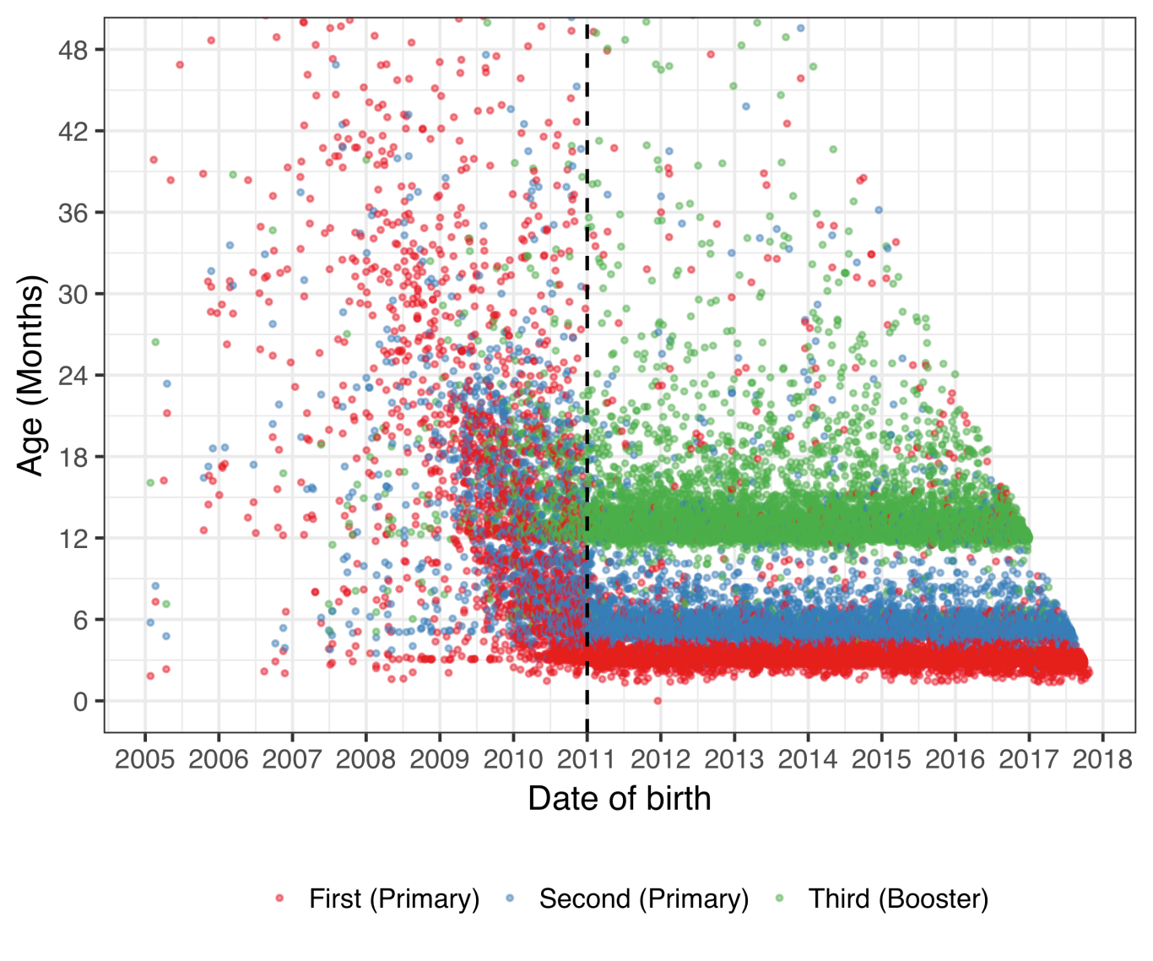

Figure 3 Age at the time of administered pneumococcal vaccine dose by birth date

### The National Drug Prescription Registry

The National Drug Prescription Registry (NDPR) recorded all filled prescriptions from 2005-2017. From this registry, all antibacterials for systemic use (J01), vaccines (J07), opthalmologicals (S01) and otologicals (S02) were extracted. A total of 4,020,624 prescriptions were recorded among 360,560 individuals. The number of prescriptions by therapeutic subgroup of the ATC classification system is shown in Table 13. The highest number of antimicrobial prescriptions filled by a single individual was 336 during the study period.

Table 13 Number of prescriptions by Anatomical Therapeutic Chemical codes used in the current study

|  |  |  |
| --- | --- | --- |
| ATC chemical subgroup code | Description | No of prescriptions |
| J01A | Tetracyclines | 357,498 |
| J01B | Amphenicols | 0 |
| J01C | Beta-lactam antibacterials, penicillins | 1,720,661 |
| J01D | Other beta-lactam antibacterials | 106,757 |
| J01E | Sulfonamides and trimethoprim | 168,045 |
| J01F | Macrolides, lincosamides and streptogramins | 344,098 |
| J01G | Aminoglycoside antibacterials | 71 |
| J01M | Quinolone antibacterials | 135,864 |
| J01R | Combinations of antibacterials | 0 |
| J01X | Other antibacterials | 96,318 |
| J07A | Bacterial vaccines | 9,687 |
| J07B | Viral vaccines | 16,703 |
| J07C | Bacterial and viral vaccines | 496 |
| J07X | Other vaccines | 0 |
| S01A | Anti-infective opthalmologicals | 287,904 |
| S02A | Anti-infective otologicals | 1 |
| S01C | Anti-inflammatory agents and anti-infectives opthalmologicals | 40,315 |
| S02C | Anti-inflammatory agents and anti-infectives otologicals | 25,218 |

The distribution of antimicrobial prescriptions by age is shown in Figure 4.

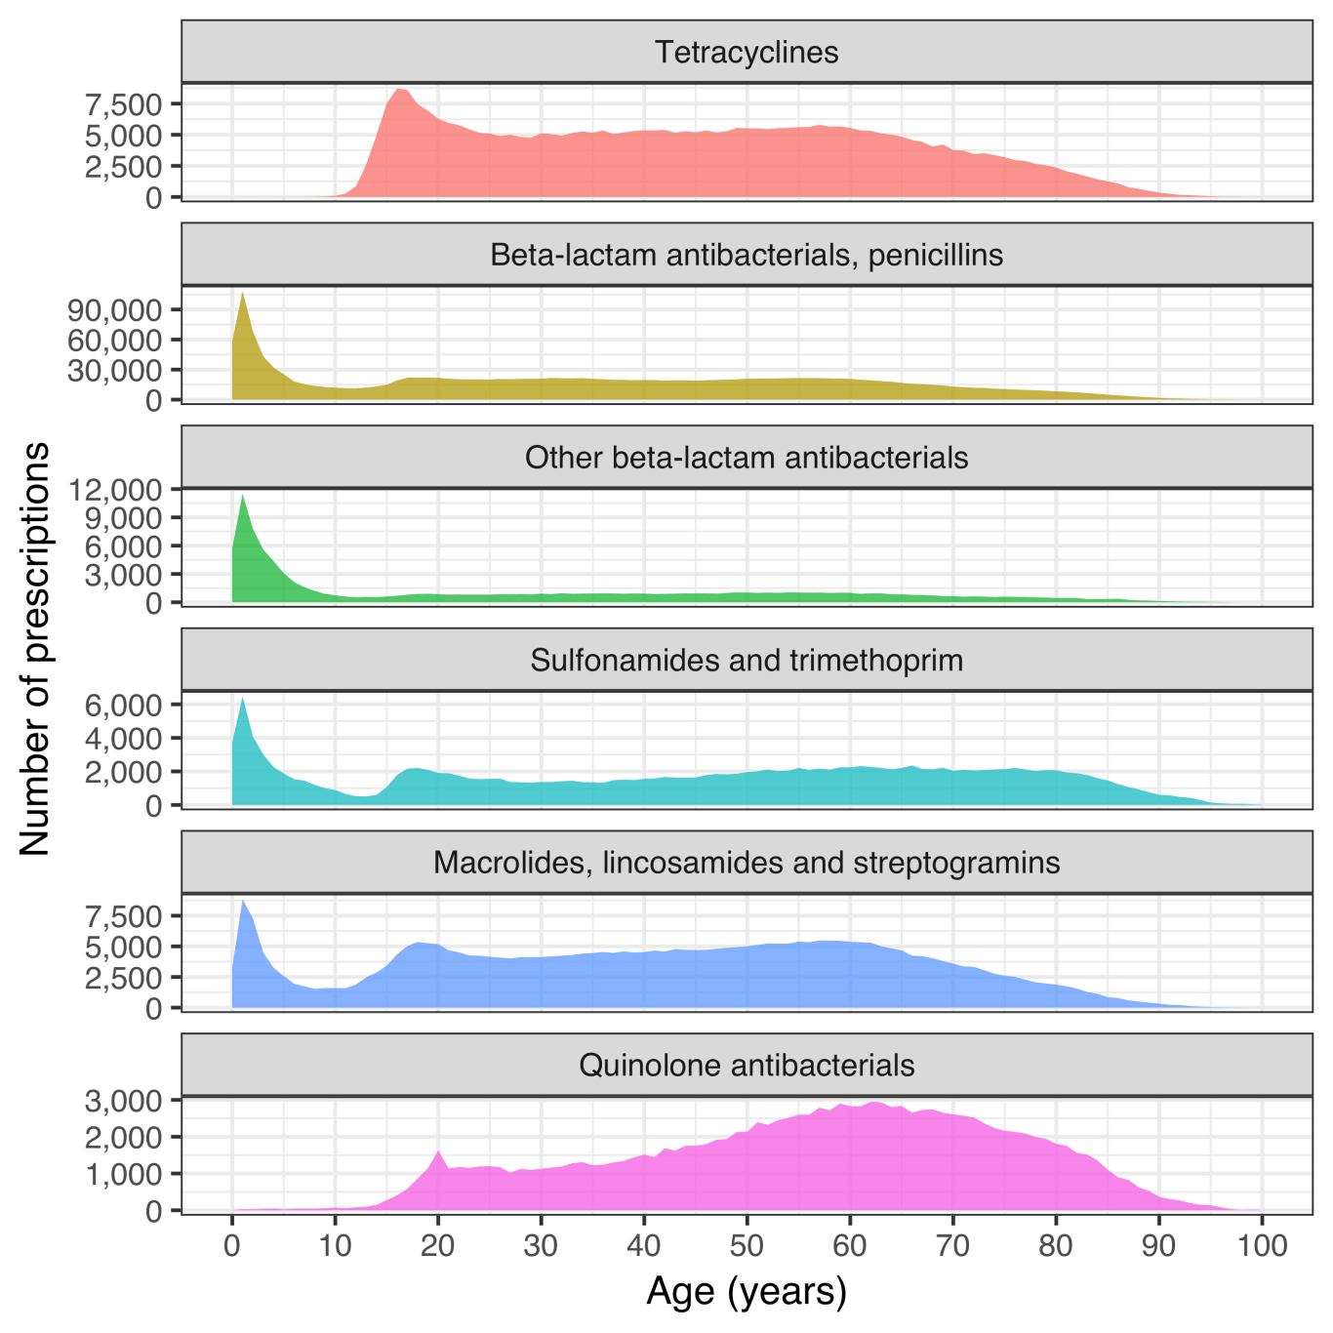

Figure 4 Antimicrobial prescriptions by age

### Reimbursement database of Icelandic Health Insurance

All interactions with independent health care practitioners were recorded in Icelandic Health Insurance’s reimbursement database. From this database, all records of otolaryngological procedures were extracted. A total of 51,814 procedures were recorded among 34,084 individuals.

## Impact on otitis media with treatment failure (Paper I)

The total number of children under eighteen years of age who lived within Children’s Hospital Iceland’s referral region remained stable during the study period, decreasing from 62,067 in 2008 to 61,798 in 2015. The variation was more pronounced in the number of children under four years of age in the same region, which increased from 13,562 in 2008 to 14,644 in 2011, and then decreased to 13,272 in 2015.

During the period January 1, 2008 to December 31, 2015, 103,220 visits were recorded to the Children’s Hospital Iceland. The visits varied over the calendar year, spiking in the winter months and troughing in the summer months. The total number of visits increased steadily during the study period, from 12,229 in 2008 to 14,502 in 2015, as seen in Figure 5.

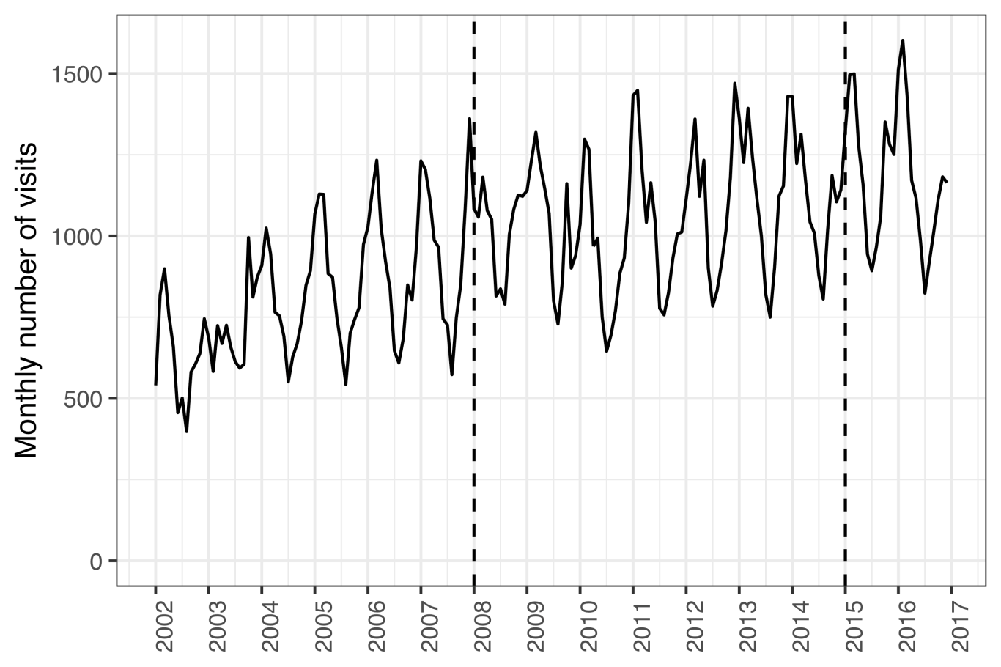

Figure 5 Monthly number of visits to Children’s Hospital Iceland

During the same period, 6,232 visits to the Children’s Hospital Iceland for acute otitis media were recorded for 4,624 individual children under four years of age, representing 4,994 distinct episodes. Of those episodes, 531 were treated with one or more doses of ceftriaxone. The total number of visits, visits for AOM and ceftriaxone treatment episodes are shown in Table 14,

Table 14 Incidence rates of visits to Children’s Hospital Iceland and parenteral ceftriaxone by calendar-year

|  |  |  |  |  |  |  |
| --- | --- | --- | --- | --- | --- | --- |
| Year | Total (n) | AOM (n) | Total (n) | AOM (n) | Total (n) | AOM (n) |
| 2008 | 197 (12,229) | 69 (936) | 80.8 (988) | 186 (174) | 15.9 (988) | 72.9 (174) |
| 2009 | 199 (12,514) | 72 (1,012) | 74.8 (936) | 192 (194) | 14.9 (936) | 66.5 (194) |
| 2010 | 181 (11,339) | 64.2 (925) | 81 (918) | 253 (234) | 14.6 (918) | 63.7 (234) |
| 2011 | 201 (12,645) | 60.8 (890) | 63.8 (807) | 178 (158) | 12.8 (807) | 55.1 (158) |
| 2012 | 215 (13,150) | 58.4 (830) | 52.5 (691) | 163 (135) | 11.3 (691) | 48.6 (135) |
| 2013 | 221 (13,518) | 55.2 (772) | 54.7 (739) | 105 (81) | 12.1 (739) | 52.8 (81) |
| 2014 | 216 (13,323) | 52 (708) | 48.9 (652) | 76.3 (54) | 10.6 (652) | 47.9 (54) |
| 2015 | 235 (14,502) | 55.1 (731) | 56.7 (822) | 88.9 (65) | 13.3 (822) | 61.9 (65) |

The incidence rate of AOM visits to Children’s Hospital Iceland decreased significantly in the post-vaccine period as compared to the pre-vaccine period; from 47.4 visits per 1000 person-years to 41.8 per 1000 person-years. The crude IRR was 0.88 (95% CI: 0.83–0.93; P < 0.001). Manel-Haenszel adjustment was not appropriate due to effect heterogeneity ( $χ^{2}$ = 15.2, P < 0.001). When each age-group was examined separately, a significant decrease in AOM visits was observed among children between one and two years of age (IRR 0.89; 95% CI: 0.93-0.96; P = 0.00341) and between two and three years of age (IRR 0.79; 95% CI: 0.71–0.88; P < 0.001), as shown in Table 15. Children under one year of age and children between three and four years of age, visited the Children’s Hospital Iceland because of AOM 471 times and 379 times, respectively.

Table 15 Incidence rate ratios of AOM visits between the pre- and post-vaccine periods

|  |  |  |  |
| --- | --- | --- | --- |
| Age (years) | IRR (95% CI) | Chi-squared | P-value |
| <1 | 1.10 (0.90-1.30) | 0.80 | 0.370 |
| 1-2 | 0.89 (0.83-0.96) | 8.60 | 0.003 |
| 2-3 | 0.79 (0.71-0.88) | 17.00 | <0.001 |
| 3-4 | 1.00 (0.85-1.30) | 0.22 | 0.639 |

Independent of this decrease in visits, the incidence of ceftriaxone treatment episodes for AOM was also found to decrease significantly in the post-vaccine period compared to the pre-vaccine period. The effect was heterogeneous across age-strata ( $χ^{2}$ = 57, P < 0.001) and the crude overall IRR was 0.48 (95% CI: 0.40–0.58; P < 0.001). The stratum specific results are shown in Table 16. During study period, only 17 episodes of AOM were treated with ceftriaxone among children zero to one years of age and 19 episodes among children three to four years of age.

Table 16 Incidence rate ratios of ceftriaxone treatment episodes of AOM between the pre- and post-vaccine periods

|  |  |  |  |
| --- | --- | --- | --- |
| Age (years) | IRR (95% CI) | Chi-squared | P-value |
| <1 | 0.61 (0.19-1.80) | 0.96 | 0.326 |
| 1-2 | 0.47 (0.37-0.60) | 41.00 | <0.001 |
| 2-3 | 0.47 (0.32-0.68) | 18.00 | <0.001 |
| 3-4 | 0.85 (0.31-2.30) | 0.12 | 0.732 |

Part of the observed decrease of ceftriaxone treatment episodes for AOM could conceivably be explained by a decrease in the number of AOM cases presenting to the Children’s Hospital Iceland. Because of this possibility, the risk of receiving ceftriaxone treatment if presenting to Children’s Hospital Iceland with AOM was calculated and a significant decrease was noted. The risk decrease was not homogeneous across age-strata ( $χ^{2}$ = 33.8, P < 0.001) and the overall relative risk ratio of 0.58 (95% CI: 0.48-0.69; P < 0.001). The stratum specific effects are shown in Table 17

Table 17 Incidence risk ratio of ceftriaxone treatment episodes of AOM adjusted for the number of AOM visits between the pre- and post-vaccine periods

|  |  |  |  |
| --- | --- | --- | --- |
| Age (years) | IRR (95% CI) | Chi-squared | P-value |
| <1 | 0.56 (0.17-1.70) | 1.30 | 0.258 |
| 1-2 | 0.53 (0.42-0.67) | 26.00 | <0.001 |
| 2-3 | 0.59 (0.40-0.86) | 7.50 | 0.006 |
| 3-4 | 0.81 (0.29-2.20) | 0.19 | 0.662 |

Decreases were noted in the incidence of AOM visits, in ceftriaxone treatment episodes of AOM and in risk of ceftriaxone treatment if presenting to the Children’s Hospital Iceland. A similar decrease was noted in the ceftriaxone treatment episodes for pneumonia. In the pre-vaccine period, 251 treatment episodes were recorded but in the postvaccine period, only 90were noted. The effect was not consistent across age-strata ( $χ^{2}$ = 72, P-value < 0.001). The overall incidence rate ratio was 0.37 (95% CI: 0.29-0.47; P < 0.001). The stratum specific effects are shown in Table 18.

Table 18 Incidence risk ratio of ceftriaxone treatment episodes of pneumonia between the pre- and post-vaccine periods

|  |  |  |  |
| --- | --- | --- | --- |
| Age (years) | IRR (95% CI) | Chi-squared | P-value |
| <1 | 0.15 (0.017-0.64) | 8.6 | 0.003 |
| 1-2 | 0.34 (0.220-0.51) | 33.0 | <0.001 |
| 2-3 | 0.36 (0.230-0.54) | 28.0 | <0.001 |
| 3-4 | 0.51 (0.290-0.89) | 6.4 | 0.012 |

To ascertain whether a decrease in ceftriaxone use had occured in vaccinated children for non-vaccine related indications, the incidence of ceftriaxone for all other indications was examined, and was shown not to change significantly in children under four years of age. There was no heterogeneity across age-strata ( $χ^{2}$ = 0.56, P-value = 0.455). The Mantel-Haenszel adjusted incidence rate ratio was 0.96 (95% CI: 0.87-1.06; P = 0.262). The number of treatment episodes by age and vaccine period ranged from 117 to295. The stratum specific incidence rate ratios are shown in Table 19.

Table 19 Incidence risk ratio of ceftriaxone treatment episodes with indications other than AOM and pneumonia between the pre- and post-vaccine periods

|  |  |  |  |
| --- | --- | --- | --- |
| Age (years) | IRR (95% CI) | Chi-squared | P-value |
| <1 | 1.30 (1.10-1.50) | 7.60 | 0.006 |
| 1-2 | 0.86 (0.70-1.00) | 2.40 | 0.121 |
| 2-3 | 0.73 (0.58-0.91) | 8.00 | 0.005 |
| 3-4 | 0.90 (0.70-1.20) | 0.62 | 0.432 |

Quarterly incidence of ceftriaxone treatment episodes by indication are shown in Figure 6.

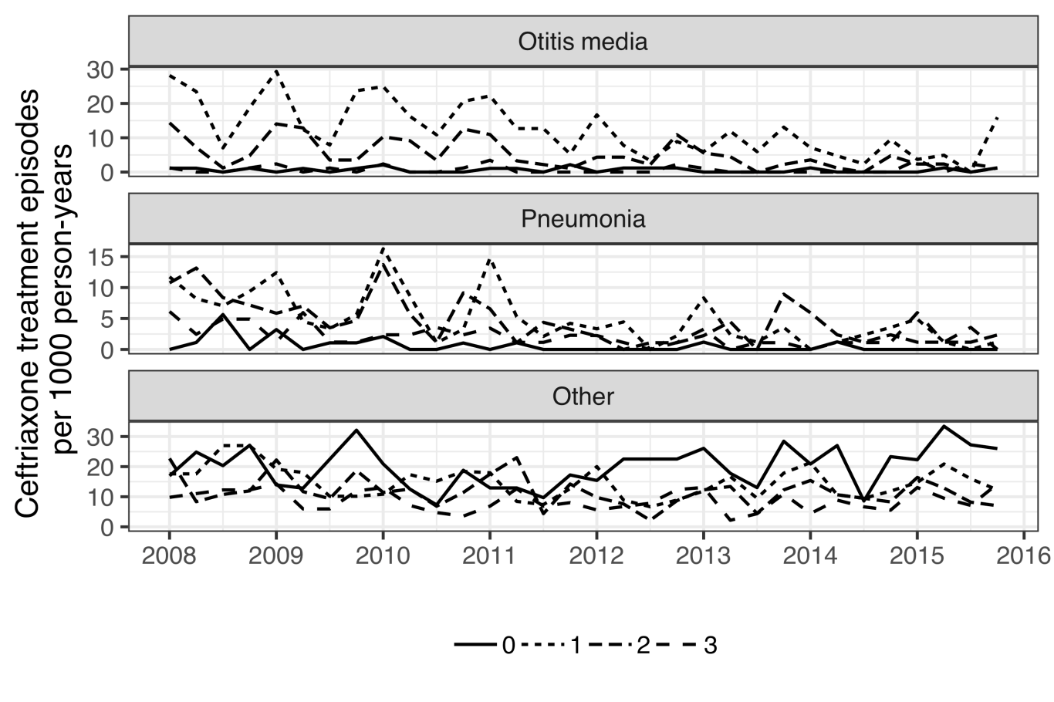

Figure 6 Quarterly incidence of ceftriaxone treatment episodes by indication 2008-2015

To further test whether a general decrease was occurring in the overall use of ceftriaxone, rather than a specific decrease for vaccine-related indications in vaccinated children, an examination of ceftriaxone treatment episodes in all children regardless of age and indication was undertaken. An overall decrease in the incidence rate of ceftriaxone treatment episodes was noted in the post-vaccine compared to the pre-vaccine period, among children under eighteen years of age regardless of indication. These rates declined from 11.11 treatment episodes per 1000 person-years to 9.55 episodes per 1000 person-years, IRR 0.86 (95% CI: 0.81-0.91; P < 0.001). The effect was not consistent across age-groups ( $χ^{2}$ = 23.6, P-value < 0.001). When examined by age-group, the overall decrease proved to be drivenby a decrease in the youngest– ie. the children who were protected by the vaccination. The incidence of ceftriaxone treatment episodes did not decrease significantly in other age groups (Figure 7).

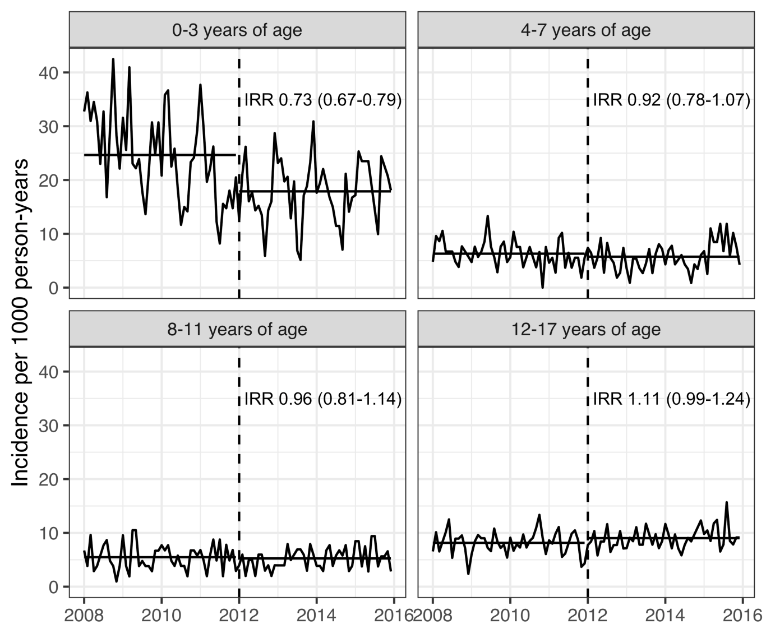

Figure 7 Incidence of ceftriaxone treatment episodes by age-group and calendar time

## Impact on primary care visits for otitis media (Paper II)

The demographics of the study birth-cohorts are described in Chapter 5.1 and Table 9. A total of 92,935 primary care visits due to AOM were recorded among birth-cohorts 2005-2015 during the study period. The crude incidence rate of AOM visits to primary care per 100 person-years in the VNEC and VEC was 45.3 and 39.8 respectively. The incidence rate and number of AOM visits by birth-cohortand gender is shown in Table 20.

Table 20 Incidence rate and number of visits by birth-cohort and gender

|  |  |  |
| --- | --- | --- |
| Birth-cohort | Females | Males |
| 2005 | 41.9 (2,777) | 49.0 (3,439) |
| 2006 | 46.1 (3,096) | 50.9 (3,605) |
| 2007 | 45.7 (3,118) | 50.3 (3,646) |
| 2008 | 46.2 (3,259) | 45.3 (3,419) |
| 2009 | 40.9 (2,981) | 47.0 (3,649) |
| 2010 | 45.0 (3,207) | 47.0 (3,523) |
| 2011 | 39.1 (2,631) | 44.1 (3,164) |
| 2012 | 40.6 (2,760) | 41.8 (2,977) |
| 2013 | 38.0 (2,125) | 42.8 (2,322) |
| 2014 | 37.4 (1,200) | 44.0 (1,465) |
| 2015 | 15.8 (157) | 20.8 (222) |

The lowest incidence was observed in children zero to three months of age. Thereafter, the incidence increased sharply, and peaked in children eight to eleven and twelve to fifteeen months of age, after which it decreased again. The crude IR decreased significantly in all age-groups, with incidence rate ratios ranging from 0.60-0.94. The largest and visually most consistent decrease in incidence was noted among children zero to three months of age, IRR 0.6 (95%CI 0.51-0.69), Figure 8

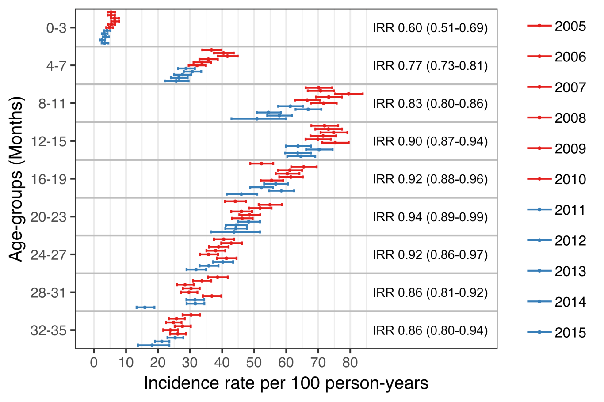

Figure 8 Incidence of acute otitis media visits to primary care by age-group and birth-cohort

When tabulated by the cumulative number of AOM episodes experienced by each child, the proportion of children experiencing zero episodes of AOM increased in the VEC compared to the VNEC, while the proportion experiencing one to four episodes and five or more decreased, as seen in Table 21.

Table 21 The proportion and 95% confidence interval for the vaccine non-eligible cohorts (VNEC, born 2005–2010) and the vaccine eligible cohorts (VEC, born 2011–2013) that recorded 0, 1–4, and 5-12 cumulative visits for AOM at 36 months of age.

|  |  |  |  |
| --- | --- | --- | --- |
| No. visits | VNEC (%) | VEC (%) | Incidence risk (95%CI) |
| 0 | 40.0 | 43.2 | 1.14 (1.10-1.18) |
| 1-4 | 55.7 | 53.2 | 0.904 (0.876-0.932) |
| 5-12 | 4.23 | 3.58 | 0.84 (0.744-0.946) |

Discrimination indices for the Andersen-Gill multiple event model were adequate, Nagelkerke’s $R^{2}$ = 0.110 and Somer’s $D_{xy}$ = 0.238. A diagnostic plot of Schoenfeld residuals was used to visually assess the proportional hazard assumption for each covariate, and no systematic deviations were detected. The model was used to estimate the hazard ratio between each of the study’s birth-cohorts and the last vaccine non-eligible cohort, 2010. There was little variation in the hazard of AOM between the VNEC. Only the 2007 birth-cohort differed significantly, with a hazard ratio of 1.06 (95%CI 1.01-1.12) compared to the 2010 birth-cohort. An abrupt and significant decrease in the hazard of AOM was noted in the first vaccine eligible cohort, which continued for all remaining VEC (Figure 9). The estimated impact of PHiD-CV10 on AOM visits to primary care among children under three years of age was 21% (95%CI 11%-30%).

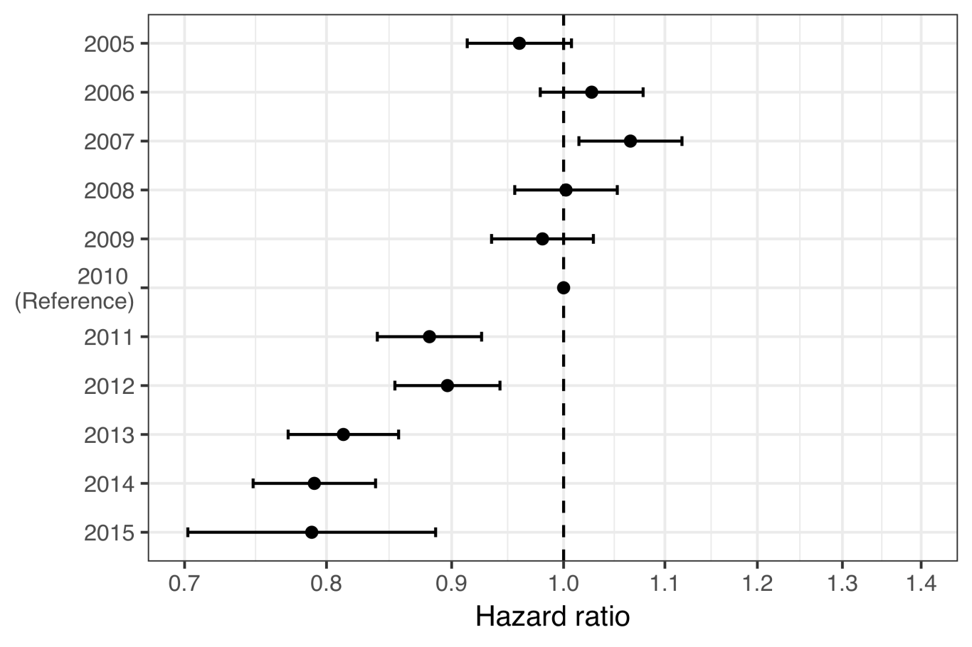

Figure 9 Estimated hazard ratio between each of the study’s birth-cohorts and the last vaccine non-eligible birth-cohort

When the hazard ratio of AOM visits between VEC and VNEC was stratified by the number of previous AOM primary care visits, the vaccine impact was discernable in children who had either no or only one previous AOM visit. With any more than one previous AOM visit, no effect was found (Figure 10).

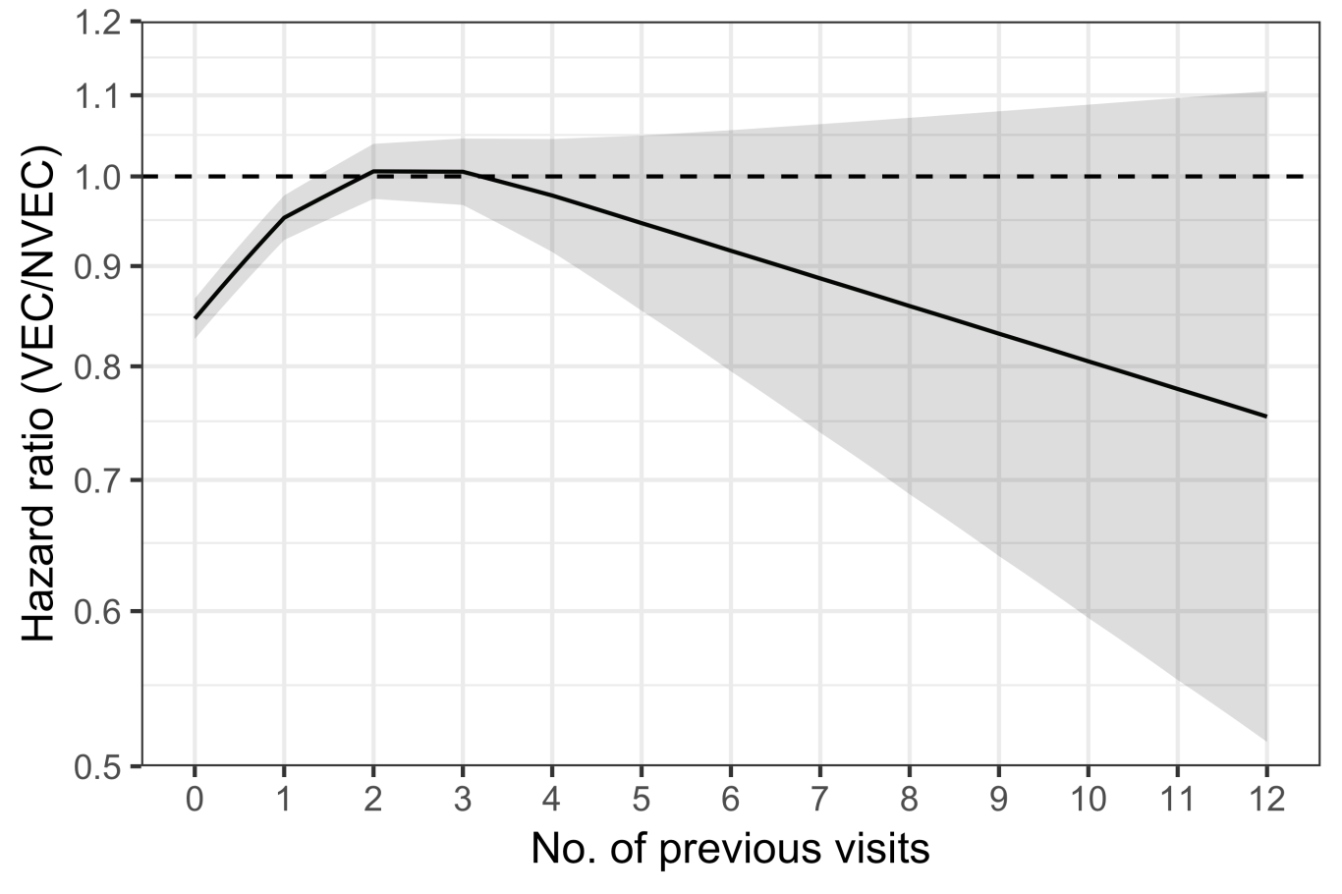

Figure 10 Estimated hazard ratio of AOM between VEC and VNEC stratified by the number of previous visits

The mean number of AOM visits to primary care as a function of age was calculated using the generalized Nelson-Aalen estimate on the underlying Andersen-Gill model. By their fourth birthday, the average child in the VNEC had experienced 1.61 episodes of AOM. The average child in the VEC had experienced 1.37. The mean number of AOM episodes by age is shown in Figure 11.

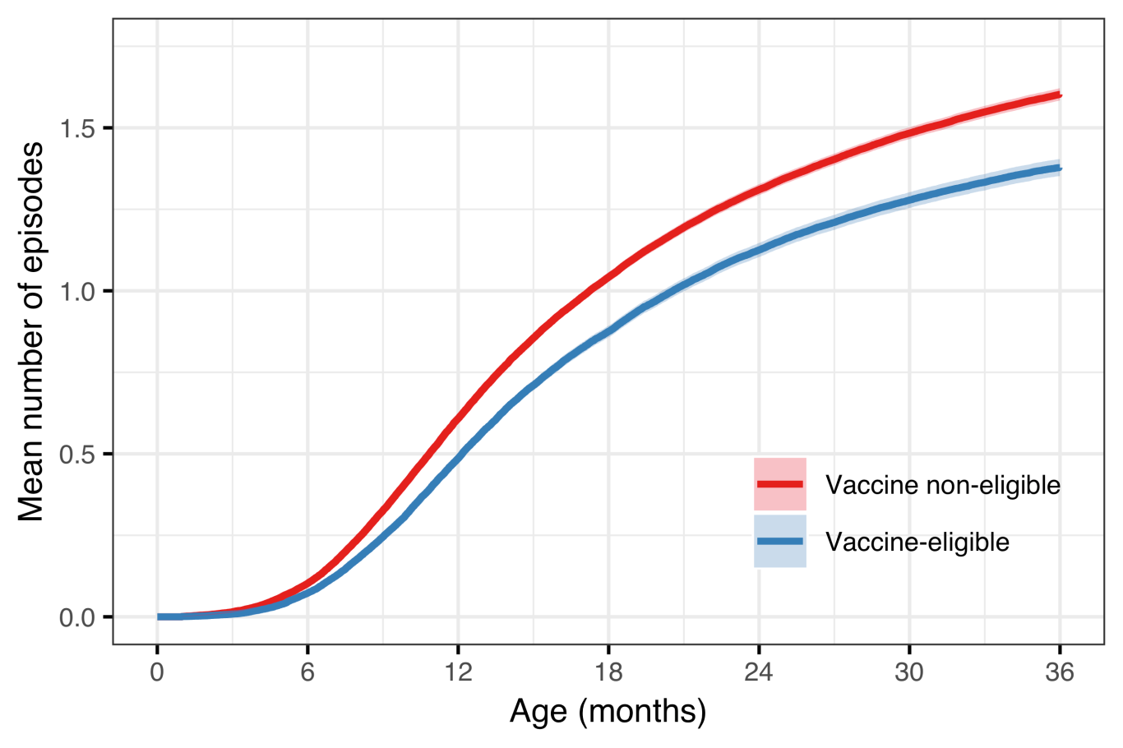

Figure 11 Mean number of AOM episodes by age in the vaccine eligible and vaccine non-eligible cohorts

## Impact on outpatient antimicrobial prescriptions (Paper III)

Demographic data regarding the study birth-cohorts is summarized in Chapter 5.1 and Table 9. From 2005-2012, first-line penicillins were prescribed most commonly and represented between 41% and 47% of all antimicrobial prescriptions. Their use decreased suddenly in 2013 to 32%, and represented only 18% of all antimicrobial prescriptions in 2014 and 2015. During this same period, the use of second-line penicillins went from 35% to 40% 2005-2012, and to 48%, 55% and 54% in 2013, 2014 and 2015. Use of cephalosporins followed a similar trend – their use represented between 5.2% and 7.8% of all prescriptions in 2005–2012, and increased to 10–15% between 2013–2016. Antimicrobial prescriptions by calendar year are shown in Table 22.

Table 22 Incidence rate and number of outpatient antimicrobial prescriptions by birth-cohort and gender

|  |  |  |  |  |  |  |  |  |
| --- | --- | --- | --- | --- | --- | --- | --- | --- |
| Calendar year | No. prescriptions | Incidence per 100 person-years | First-line penecillin | Second-line penecillin | First-generation macrolide | Second-generation macrolide | Cephalosporin | Other |
| 2005 | 25,649 | 204.0493 | 41.41 | 37.92 | 1.48 | 6.55 | 5.37 | 7.26 |
| 2006 | 26,396 | 205.5123 | 40.34 | 39.57 | 1.27 | 6.22 | 5.36 | 7.24 |
| 2007 | 25,179 | 192.0448 | 44.97 | 36.80 | 1.60 | 6.39 | 5.16 | 5.08 |
| 2008 | 24,046 | 178.4622 | 46.74 | 35.22 | 0.20 | 6.37 | 5.91 | 5.57 |
| 2009 | 22,409 | 159.3586 | 46.41 | 37.16 | 0.05 | 5.51 | 6.33 | 4.55 |
| 2010 | 24,007 | 166.9239 | 43.71 | 38.55 | 0.02 | 5.54 | 7.02 | 5.17 |
| 2011 | 23,866 | 163.6002 | 44.70 | 37.92 | 0.03 | 5.91 | 7.47 | 3.98 |
| 2012 | 22,703 | 159.5993 | 43.45 | 39.01 | 0.01 | 6.92 | 7.77 | 2.83 |
| 2013 | 21,113 | 151.9686 | 32.10 | 48.08 | 0.02 | 6.56 | 10.03 | 3.20 |
| 2014 | 20,325 | 151.7924 | 18.48 | 55.46 | 0.01 | 6.60 | 14.53 | 4.92 |
| 2015 | 19,873 | 149.6010 | 18.49 | 53.91 | 0.06 | 7.25 | 14.95 | 5.34 |
| 2016 | 20,543 | 160.3294 | 35.28 | 41.68 | 0.04 | 5.52 | 12.91 | 4.57 |

The proportion of visits resulting in antimicrobial prescription and the incidence of antimicrobial prescriptions linked to each of the study’s diagnostic groups are shown in Figure 12. The proportion of otitis media visits resulting in an antimicrobial prescription remained stable at between 57% and 64% of all visits. The incidence of otitis media-associated prescriptions decreased from a high of 54.9 prescriptions per 100 person-years in 2008 to 39.8 prescriptions per 100 person-years in 2015.

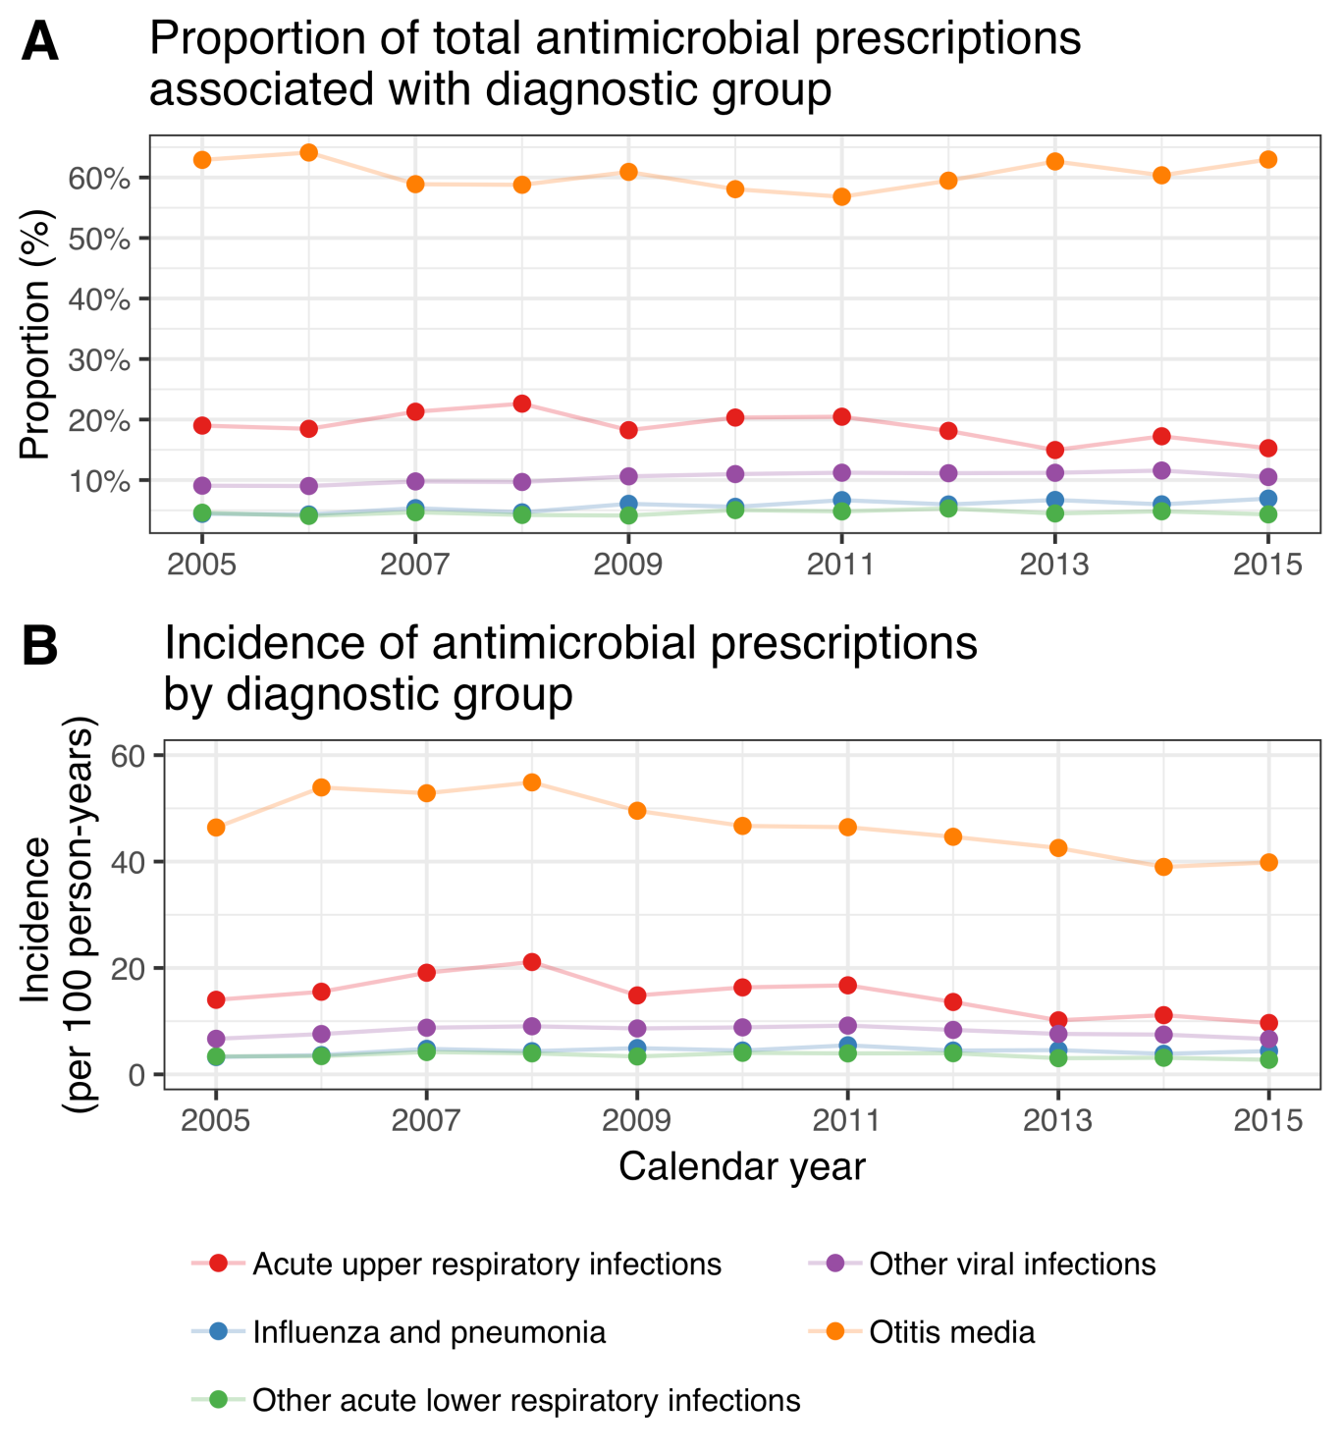

Figure 12 Proportion of visits due to each diagnostic group resulting in antimicrobial prescription, and incidence of associated antimicrobial prescriptions

During the study period, a total of 226,084 outpatient antimicrobial prescriptions were recorded among birth-cohorts 2005-2015. The crude incidence rate of outpatient antimicrobial prescriptions per 100 person-years in the VNEC and VEC was 164.6 and 150.2 respectively. The incidence rate and number of outpatient antimicrobial prescriptions by birth-cohortand gender is shown in Table 23.

Table 23 Incidence rate and number of outpatient antimicrobial prescriptions by birth-cohort and gender

|  |  |  |
| --- | --- | --- |
| Birth-cohort | Females | Males |
| 2005 | 176.0 (11,178) | 200.0 (13,423) |
| 2006 | 167.0 (10,843) | 190.0 (13,109) |
| 2007 | 153.0 (10,140) | 174.0 (12,339) |
| 2008 | 153.0 (10,543) | 171.0 (12,492) |
| 2009 | 151.0 (10,699) | 169.0 (12,775) |
| 2010 | 150.0 (10,366) | 161.0 (11,854) |
| 2011 | 142.0 ( 9,230) | 156.0 (10,906) |
| 2012 | 142.0 ( 9,447) | 158.0 (11,058) |
| 2013 | 138.0 ( 9,015) | 158.0 (10,180) |
| 2014 | 145.0 (7,726) | 167.0 (9,234) |
| 2015 | 138.0 (4,075) | 173.0 (5,452) |

The lowest incidence was observed in children zero to five months of age. The incidence increased sharply thereafter and peaked in children six to eleven and twelve to seventeen months of age, after which it decreased again. The crude IR decreased significantly in all age-groups, with incidence rate ratios ranging from 0.82-0.94. The largest and visually most consistent decrease in incidence was noted among children zero to five months of age, IRR 0.82 (95%CI 0.79-0.85) (Figure 13).

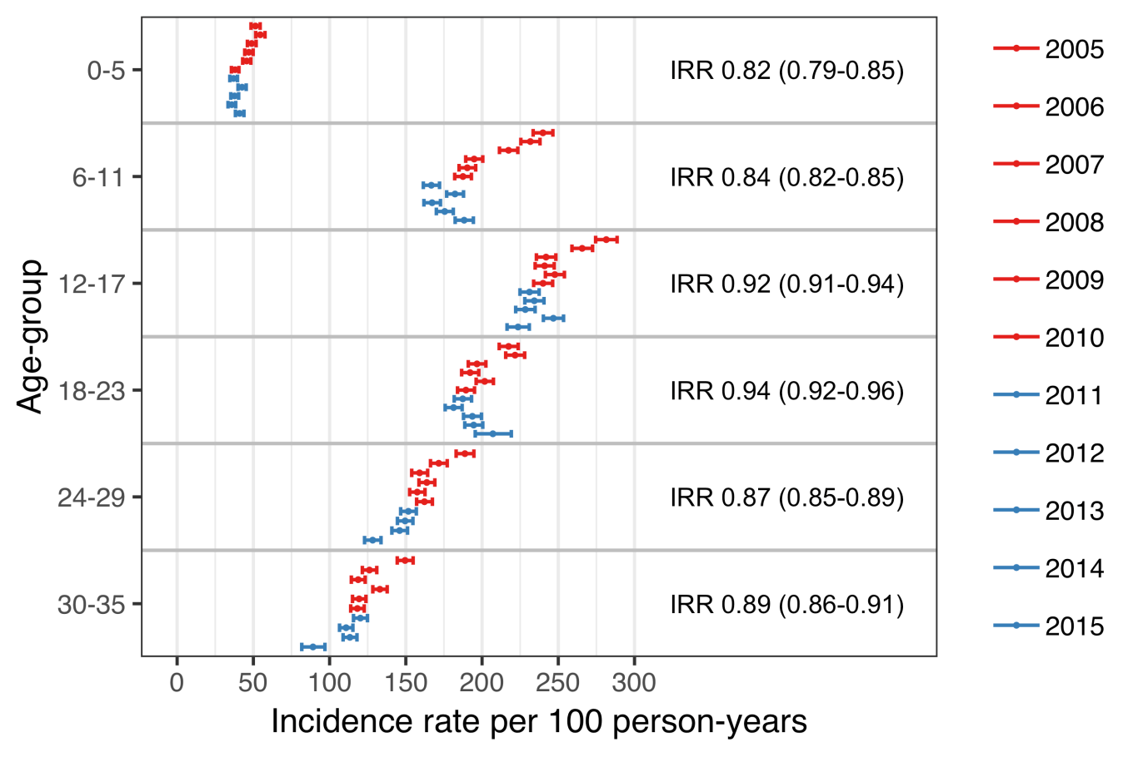

Figure 13 Incidence of outpatient antimicrobial prescriptions by age-group and birth-cohort

The proportion of children in the VNEC and VEC who filled at least one antimicrobial prescription by three years of age was 88.6% and 86.8 respectively. Children in the VEC were significantly more likely than children in the VNEC not to have filled an antimicrobial prescription (incidence risk ratio 1.16, 95%CI 1.10-1.23) or to have filled only between one and four antimicrobial prescriptions (incidence risk ratio 1.08, 95%CI 1.06–1.11). The cumulative number of prescriptions by vaccine eligibility cohort in shown in Table 24.

Table 24 The proportion of children in the vaccine non-eligible cohorts (VNEC, born: 2005–2010) and vaccine eligible cohorts (VEC, born 2011–2013) who filled 0, 1–4, 5–9, 10–14 and ≥ 15 prescriptions by 36 months of age.

|  |  |  |  |
| --- | --- | --- | --- |
| No. prescriptions | VNEC (%) | VEC (%) | Incidence risk (95%CI) |
| 0 | 11.4 | 13.2 | 1.16 (1.10-1.23) |
| 1-4 | 43.7 | 47.3 | 1.08 (1.06-1.11) |
| 5-9 | 31.6 | 29.0 | 0.918 (0.889-0.947) |
| 10-14 | 9.79 | 7.52 | 0.768 (0.716-0.823) |
| ≥15 | 3.51 | 2.91 | 0.831 (0.74-0.934) |

Discrimination indices for the Andersen-Gill multiple event model were adequate, Nagelkerke’s $R^{2}$ = 0.212 and Somer’s $D_{xy}$ = 0.295. A diagnostic plot of Schoenfeld residuals was used to visually assess the proportional hazard assumption for each covariate - no systematic deviations were detected. The model was used to estimate the hazard ratio of outpatient antimicrobial prescriptions between each of the study’s birth-cohorts and the last vaccine non-eligible cohort, 2010. Visually, there seemed to be a decreasing trend in hazard among the vaccine non-eligible birth-cohorts (Figure 14). The hazard did not change significantly between the last vaccine non-eligible birth-cohort and the preceeding two cohorts, but did decrease significantly thereafter, with each vaccine eligible cohort having a significantly lower hazard of outpatient antimicrobial prescription. The estimated impact of PHiD-CV10 on outpatient antimicrobial prescriptions among children under three years of age was 8% (95%CI 4%-12%).

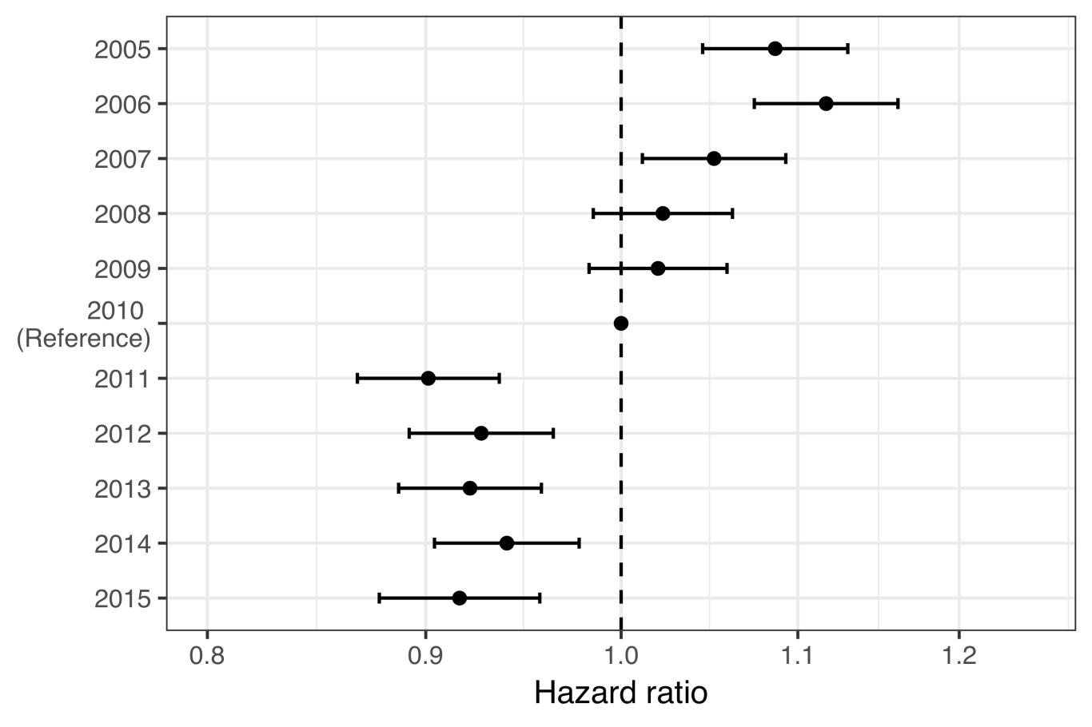

Figure 14 Estimated hazard ratio between each of the study’s birth-cohorts and the last vaccine non-eligible birth-cohort

When the hazard ratio of outpatient antimicrobial prescriptions between the VEC and VNEC was stratified by the number of previous prescriptions, the vaccine impact was discernable for children who had had up to three prior antimicrobial prescriptions., After more than three prior prescriptions, no effect was found (Figure 15).

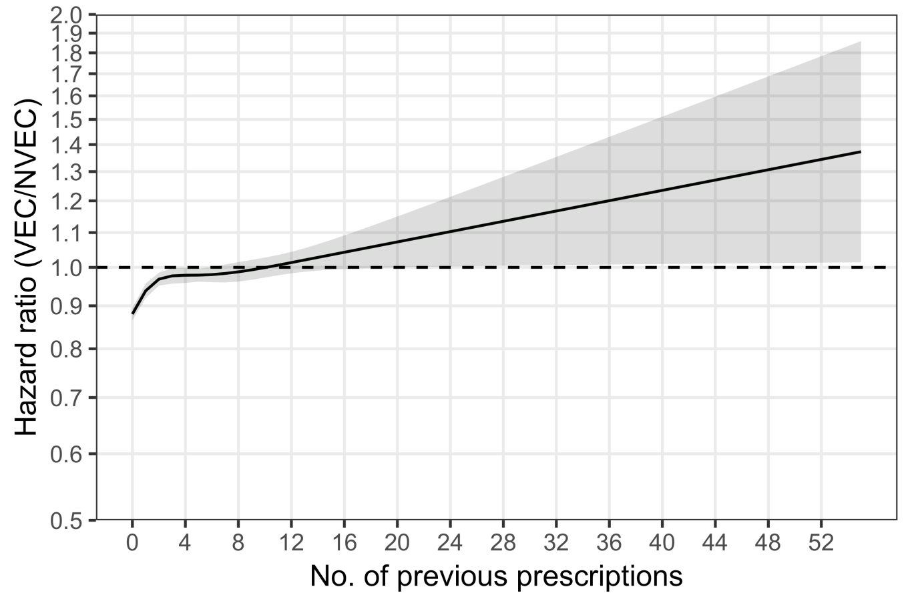

Figure 15 Estimated hazard ratio of AOM between VEC and VNEC, stratified by the number of previous visits

The mean number of outpatient antimicrobial prescriptions as a function of age was caclulated using the generalized Nelson-Aalen estimate on the underlying Andersen-Gill model. By their fourth birthday, the average male child in the VNEC had filled 6.48 antimicrobial prescriptions and the average female had filled 6.07. The average male and female in the VEC had filled 5.84 and 5.46 prescriptions respectively. The mean number of antimicrobial prescriptions by age and gender is shown in Figure 16.

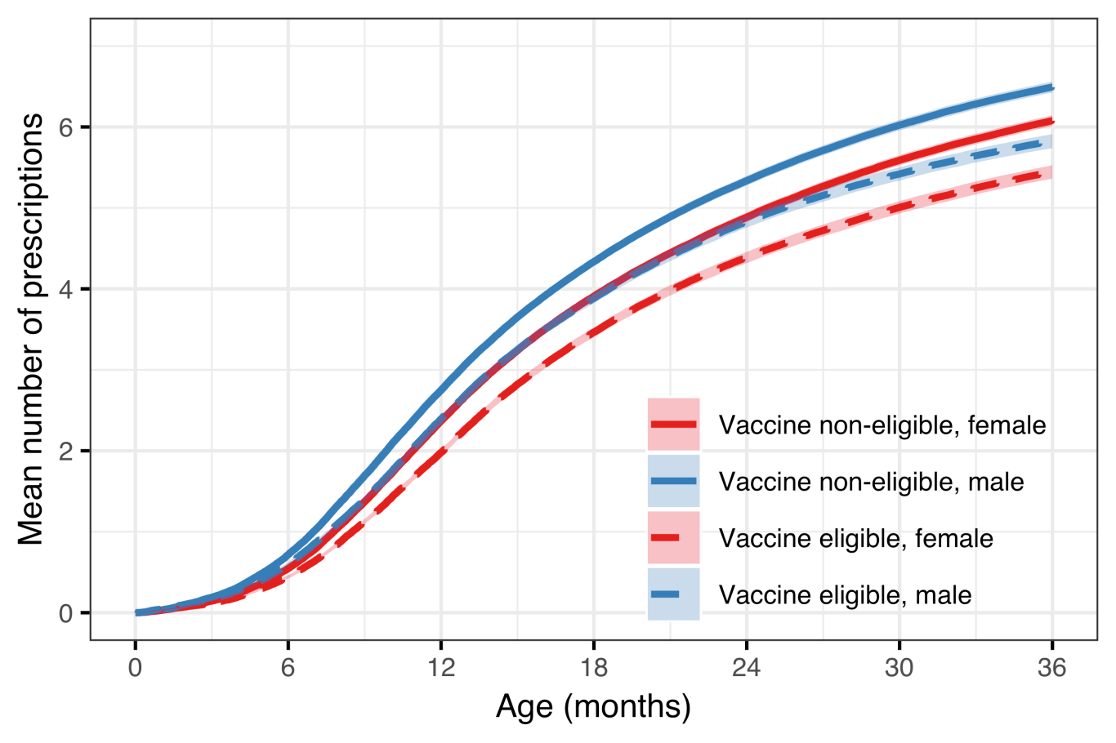

Figure 16 Mean number of AOM episodes by age in the vaccine eligible and vaccine non-eligible cohorts

## Impact on tympanostomy tube procedures (Paper IV)

Demographic data regarding the study birth-cohorts is summarized in Chapter 5.1. In total, during the study period, 14,351 children underwent 20,373 tympanostomy tube placements, 57% of whom were male. The median age of children undergoing their first tympanostomy procedure was 17 months (IQR 13-24). In the subset of children who underwent a tympanostomy tube placement during the study period, 10,248 (71%) underwent only one procedure, 2,902 (20%) underwent two, and 1201 (8%) underwent three or more. Almost all (98%) of the procedures were performed in private outpatient clinics. The number of otolaryngologists performing outpatient tympanostomy tube placements increased from 15 in 2005 to 23 in 2016. Each surgeon performed a median of 123 (IQR: 56.5-196) procedures each year. The study’s population is summarized in Table 25.

Table 25 Demographic information regarding the study’s birth-cohorts

|  |  |  |  |  |
| --- | --- | --- | --- | --- |
| Birth-cohort | Number of children | Person-years | Number of procedures (n children) | Median age (months) |
| 2005 | 4,541 | 21,409 | 1,946 (1,280) | 17 (12-25) |
| 2006 | 4,665 | 21,988 | 1,931 (1,303) | 18 (13-27) |
| 2007 | 4,770 | 22,500 | 1,974 (1,335) | 18 (13-27) |
| 2008 | 4,949 | 23,313 | 2,140 (1,428) | 18 (13-26) |
| 2009 | 5,128 | 24,141 | 2,145 (1,514) | 18 (13-25) |
| 2010 | 4,984 | 23,580 | 2,203 (1,547) | 18 (13-26) |
| 2011 | 4,642 | 22,056 | 1,997 (1,382) | 18 (13-24) |
| 2012 | 4,668 | 20,195 | 2,057 (1,419) | 16 (12-23) |
| 2013 | 4,442 | 14,964 | 1,642 (1,200) | 16 (13-23) |
| 2014 | 4,444 | 10,744 | 1,582 (1,251) | 16 (13-20) |
| 2015 | 4,136 | 5,983 | 756 (692) | 13 (11-15) |

The crude incidence rate of tympanostomy tube placements in the VEC was 10.6 procedures per 100 person-years. This was significantly higher than the crude incidence rate in the VNEC, 8.7 procedures per 100 person-years (IRR 1.20, 95%CI 1.17-1.24). When stratified by age-groups, the crude incidence rate was highest among 12-17 month old children (Figure 17).

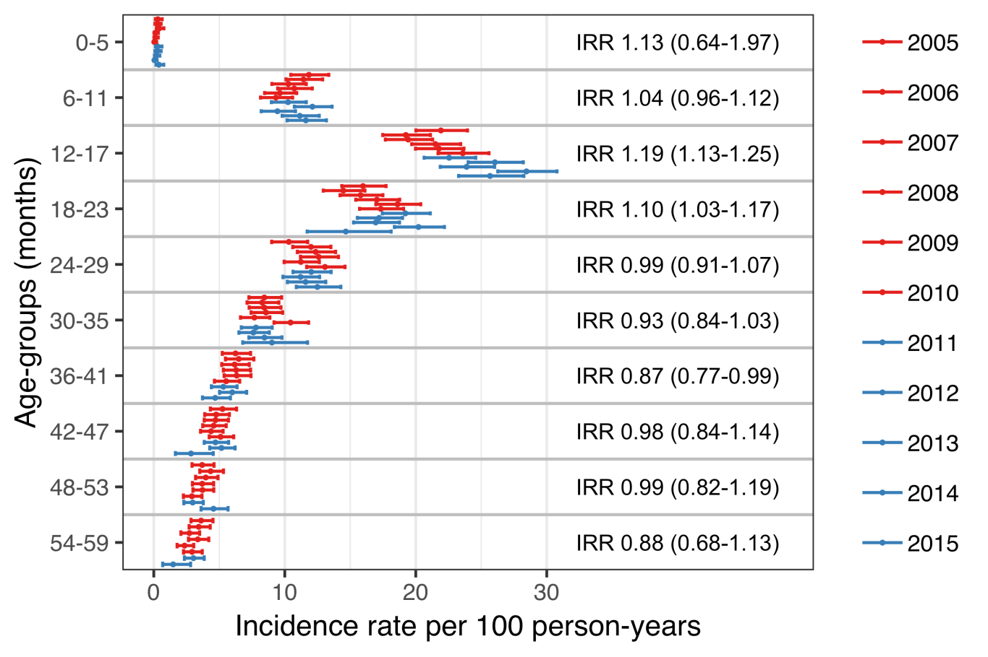

Figure 17 Incidence of tympanostomy tube procedures by age-group and birth-cohort

The cumulative proportion of children who had undergone at least one tympanostomy tube placement by five years of age was highest in birth-cohort 2010 (31.7%) and lowest in birth-cohort 2006 (28.6%), Table 26. The cumulative proportion of tympanostomy tube procedures was significantly higher in the vaccine eligible birth-cohorts compared to vaccine non-eligible cohorts regardless of age (Figure 18).

Table 26 Demographic information regarding the study’s birth-cohorts

|  |  |  |  |  |  |  |  |  |  |  |  |
| --- | --- | --- | --- | --- | --- | --- | --- | --- | --- | --- | --- |
| Age (months) | 2005 | 2006 | 2007 | 2008 | 2009 | 2010 | 2011 | 2012 | 2013 | 2014 | 2015 |
| 6 | 0.4 | 0.3 | 0.4 | 0.2 | 0.3 | 0.1 | 0.4 | 0.2 | 0.3 | 0.2 | 0.5 |
| 12 | 7.2 | 7.1 | 6.6 | 7.2 | 6.5 | 6.6 | 6.6 | 7.8 | 6.5 | 6.9 | 7.6 |
| 18 | 16.4 | 14.8 | 14.9 | 15.9 | 15.7 | 16.5 | 16.3 | 18.3 | 16.3 | 19.1 | 18.4 |
| 24 | 21.1 | 19.5 | 19.7 | 21.0 | 22.0 | 22.4 | 23.3 | 23.9 | 21.7 | 26.1 | - |
| 30 | 23.7 | 22.9 | 23.4 | 24.5 | 25.1 | 26.3 | 26.3 | 26.7 | 24.9 | 29.0 | - |
| 36 | 25.8 | 24.8 | 25.3 | 26.5 | 27.2 | 28.8 | 27.9 | 28.3 | 26.9 | - | - |
| 42 | 26.9 | 26.5 | 26.7 | 27.7 | 28.5 | 30.1 | 28.7 | 29.5 | 27.5 | - | - |
| 48 | 27.8 | 27.4 | 27.8 | 28.5 | 29.1 | 31.0 | 29.4 | 30.4 | - | - | - |
| 54 | 28.4 | 28.3 | 28.4 | 29.1 | 29.9 | 31.4 | 30.1 | 30.9 | - | - | - |
| 59 | 28.8 | 28.6 | 28.6 | 29.5 | 30.2 | 31.7 | 30.4 | 31.3 | - | - | - |

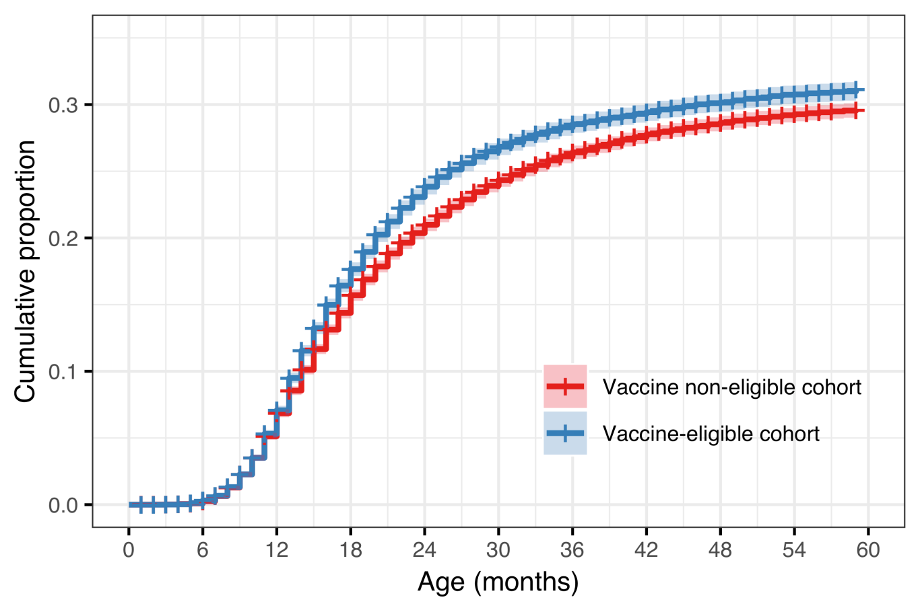

Figure 18 Cumulative proportion of children who underwent at least one tympanostomy tube placement for the vaccine eligible (VEC) and vaccine non-eligible (VNEC) cohorts

In the subset of children who underwent tympanostomy tube placement, the mean (median) number of otitis media-associated visits to primary care or to the paediatric emergency department was 2.05 (2) visits in the vaccine non-eligible cohorts, compared to 1.72 (1) visits in the vaccine eligible cohorts. The distribution in the number of previous visits was significantly different between the VNEC and VEC (Chi-Squared test statistic 63.8, P<.001). The proportion of children who did not have a single recorded visit prior to undergoing the procedure increased from 20.6% in the VNEC to 28.9% in the VEC, RR 1.40 (95%CI 1.28-1.54). Children in the VEC had received significantly fewer antimicrobial prescriptions prior to undergoing the procedure (Chi-Squared test statistic 53.6, P<.001). The mean (median) number of previous antimicrobial prescriptions was 3.19 (4) in the VEC compared to 3.62 (4) in the VNEC. Children in the VEC were more likely to have never been prescribed antimicrobials prior to undergoing tympanostomy tube placement, RR 1.52, 95%CI 1.18-1.96). The comparison between VEC and VNEC is summarized in Table 27.

Table 27 Incidence rate and number of outpatient antimicrobial prescriptions by birth-cohort and gender

|  |  |  |  |  |  |  |  |  |
| --- | --- | --- | --- | --- | --- | --- | --- | --- |
| Cumulative number | VNEC % (n) | VEC % (n) | RR (95%CI) | ARD (95%CI | VNEC % (n) | VEC % (n) | RR (95%CI) | ARD (95%CI |
| 0 | 3.43 (286) | 5.22 (72) | 1.18 (1.52 to 1.96) | 1.79 (0.51 to 3.07) | 20.60 (1,720) | 28.90 (398) | 1.28 (1.40 to 1.54) | 8.29 (5.70 to 10.900) |
| 1 | 11.60 (966) | 12.80 (177) | 0.95 (1.11 to 1.29) | 1.26 (-0.68 to 3.19) | 24.90 (2,080) | 24.40 (337) | 0.89 (0.98 to 1.09) | -0.45 (-2.94 to 2.040) |
| 2 | 19.30 (1,610) | 22.60 (311) | 1.05 (1.17 to 1.30) | 3.28 (0.87 to 5.68) | 20.40 (1,700) | 19.60 (270) | 0.85 (0.96 to 1.07) | -0.86 (-3.17 to 1.450) |
| 3-4 | 37.80 (3,150) | 37.40 (516) | 0.92 (0.99 to 1.07) | -0.39 (-3.19 to 2.41) | 24.90 (2,080) | 20.20 (279) | 0.73 (0.81 to 0.91) | -4.64 (-7.00 to -2.290) |
| 5-7 | 22.30 (1,860) | 19.30 (266) | 0.77 (0.86 to 0.97) | -3.01 (-5.32 to -0.70) | 7.98 (666) | 6.45 (89) | 0.65 (0.81 to 1.00) | -1.53 (-2.99 to -0.066) |
| 8+ | 5.61 (468) | 2.68 (37) | 0.34 (0.48 to 0.67) | -2.93 (-3.95 to -1.90) | 1.25 (104) | 0.43 (6) | 0.15 (0.35 to 0.79) | -0.81 (-1.28 to -0.348) |

A diagnostic plot of Schoenfeld residuals was used to visually assess the proportional hazard assumption for all covariates in each Cox model, and no systematic deviations were detected. The hazard of undergoing a tympanostomy tube procedure was considerably higher in children who had previously visited a physician for otitis media or received an antimicrobial prescription. Children who had one prior documented visit were considerably more likely to undergo the procedure than children who had no documented visits, HR of 3.12 (95%CI 2.93-3.32). Likewise, children who had previously filled one antimicrobial prescription were more likely to receive a tympanostomy tube than children who had received no prescription, 6.98 (95%CI 6.13-7.95). The hazard of tympanostomy tube placement increased gradually from birth-cohort 2005 to 2015 (Figure 19).

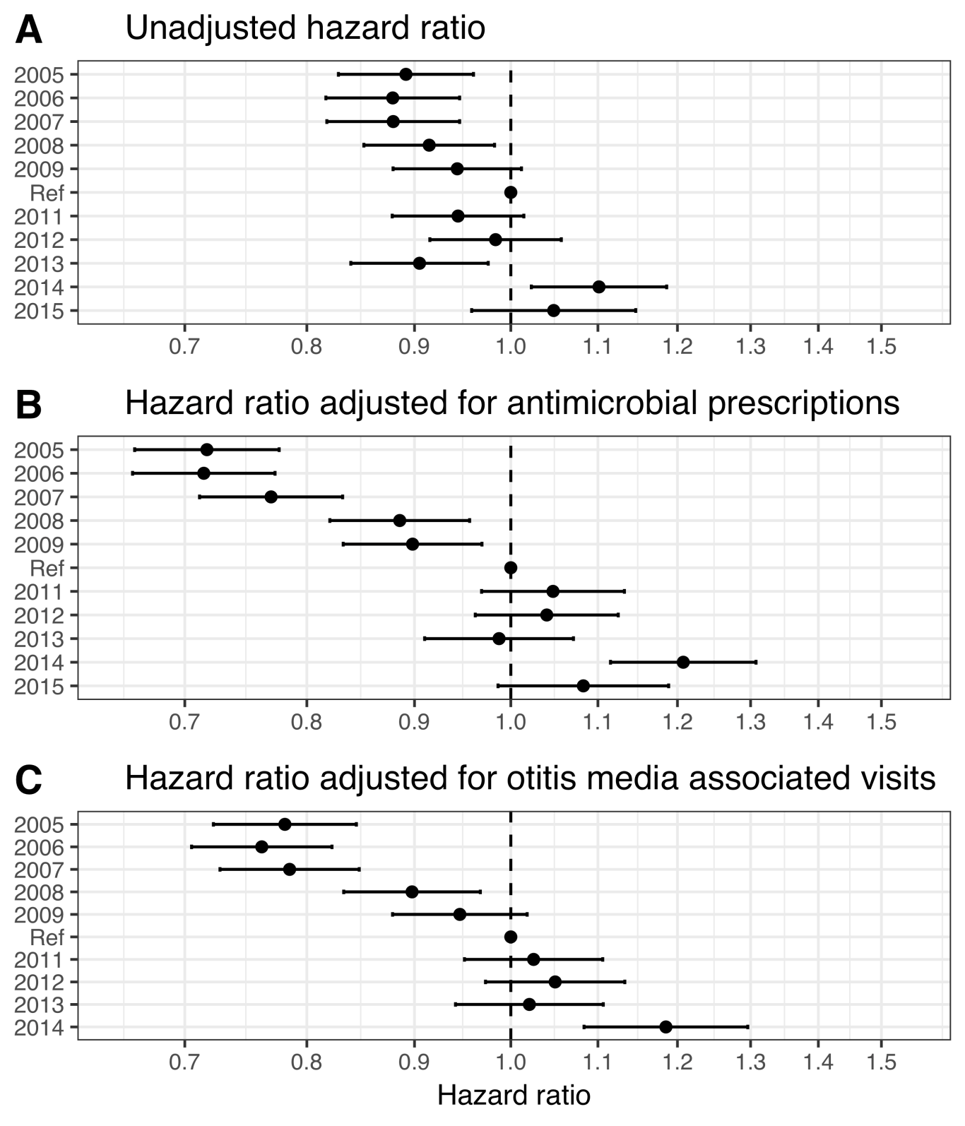

Figure 19 The hazard ratio of undergoing a tympanostomy tube placement between each of the study’s birth-cohorts (VEC) and the last vaccine non-eligible birth-cohort (VNEC)

## Impact on respiratory-associated hospitalizations (Paper V)

Demographic data regarding the study birth-cohorts are summarized in Chapter 5.1. In total, 51,264 children were followed for a median of 1,096 days (range 6-1,096) resulting in 142,315 person-years of follow-up time. Of those, 1,414 children were admitted to hospital 1,703 times with diagnoses compatible with the study’s diagnostic groups. The total number of hospital admissions regardless of indication was 4,842. An overview of the demographic data is presented in Table 28.

Table 28 Demographic information regarding the study’s birth-cohorts

|  |  |  |  |  |  |  |
| --- | --- | --- | --- | --- | --- | --- |
| Birth-cohort | Number of children | Person-years | All cause admissions, *n* | Study admissions, *n* (children, *n*) | Proportion due to study diagnosis, *%* | ICU admissions, *n* (children, *n*) |
| 2005 | 4,541 | 13,277 | 446 | 219 (160) | 49.1 | 7 (7) |
| 2006 | 4,668 | 13,658 | 415 | 176 (140) | 42.4 | 10 (8) |
| 2007 | 4,770 | 13,985 | 423 | 186 (160) | 44.0 | 6 (5) |
| 2008 | 4,953 | 14,472 | 442 | 117 (101) | 26.5 | 5 (4) |
| 2009 | 5,130 | 14,965 | 484 | 124 (109) | 25.6 | 7 (6) |
| 2010 | 4,988 | 14,592 | 384 | 158 (138) | 41.1 | 7 (7) |
| 2011 | 4,644 | 13,640 | 392 | 129 (112) | 32.9 | 4 (4) |
| 2012 | 4,668 | 13,753 | 576 | 196 (155) | 34.0 | 0 (0) |
| 2013 | 4,442 | 13,044 | 472 | 149 (119) | 31.6 | 9 (8) |
| 2014 | 4,446 | 10,930 | 431 | 144 (122) | 33.4 | 6 (5) |
| 2015 | 4,136 | 6,140 | 377 | 105 (98) | 27.9 | 3 (3) |

Of the children in the study birth-cohorts, 550 were hospitalized 660 times with ICD-10 discharge diagnoses consistent with pneumonia. In the same cohorts, 508 children were admitted 550 times with diagnoses consistent with acute lower respiratory tract infections. In the VNEC, the crude incidence rate of pneumonia requiring hospital admission was 4.94 per 1,000 person-years, which decreased to 4.18 per 1,000 in the VEC. The analogous crude incidence rate of hospitalizations for acute lower respiratory tract infections was 2.94 and 5.23 per 1,00 person-years. Though the absolute number of admissions was similar between these two groups, the distribution of cases was different. The crude incidence rate of hospital admissions for pneumonia was highest in children 12-17 months of age, while the incidence rate of hospitalizations for lower respiratory tract infections was highest in children <6 months of age (Figure 20). Children admitted for acute lower respiratory tract infections were significantly younger than children admitted for pneumonia (mean age 8.0 months and 13.6 months respectively, P<.001). Using crude age-group stratified incidence rate ratios between the vaccine eligible and non-eligible cohorts, the incidence rate of pneumonia hospitalizations was found to have decreased significantly only among children 12-17 months of age, crude incidence rate ratio 0.52 (95%CI: 0.35-0.77). Using the same method, the incidence rate of hospital admissions for acute lower respiratory tract infections admissions was found to have increased significantly among children 0-5 months of age, crude incidence rate ratio 1.50 (95%CI 1.23-1.84).

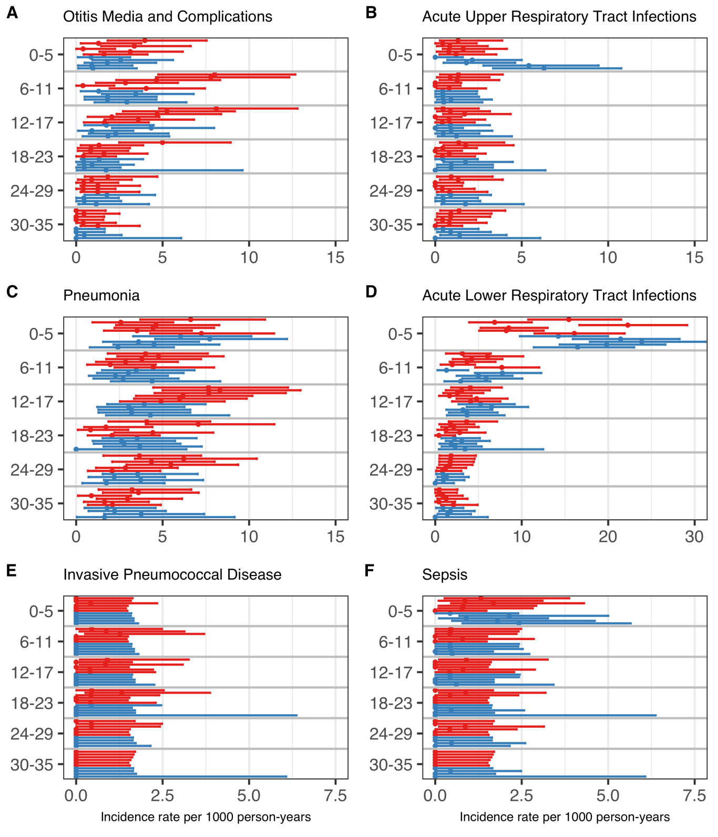

Figure 20 Incidence of hospitalization per 1,000 person-years by age- and disease-group

A significant difference was detected in the cumulative rate of hospital admissions for both pneumonia and acute lower respiratory tract infections between the vaccine eligible and non-eligible cohorts (Figure 21). The hazard ratio of hospital admission for pneumonia was 0.80 (95%CI:0.67-0.95), with an E-value of 1.81 and a lower bound of 1.29. When the risk-set was restricted to children younger than 90 days and 90 days and older, respectively, the hazard ratio was 1.22 (95%CI 0.81-1.85) and 0.73 (95%CI 0.60-0.89) respectively. The hazard ratio for hospital admission due to acute lower respiratory tract infection was 1.32 (95%CI:1.14-1.53), with an E-value of 1.97 and a lower bound of 1.54. The hazard ratio was augmented when children younger than 90 days were analysed separately, HR 1.54 (95%CI 1.23-1.94). It was not significant in children 90 days and older, HR 1.18 (95%CI 0.97-1.44).

A total of 131 hospitalizations for acute upper respiratory tract infections were recorded for 123 children. During the same period, 256 children were admitted to hospital 280 times for otitis media and complications. The crude incidence rate of hospital admissions for otitis media was higher than the incidence rate of admissions for acute upper respiratory tract infections; 2.32 and 1.45 per 1,000 person-years in the vaccine eligible and vaccine non-eligible cohorts respectively, compared to 0.78 and 1.13 per 1,000 person-years. The mean age of children admitted for acute upper respiratory tract infections was 13.5 months compared to 12.8 months for children admitted for otitis media and complications. The crude incidence rate by age-group is shown in Figure 20. The cumulative incidence rate of hospitalization per 1000 person-years for acute upper respiratory tract infections and otitis media and complications are shown in Figure 21. The hazard ratio of otitis media hospitalizations between the vaccine eligible and non-eligible cohorts was 0.57 (95%CI:0.43-0.73) with an E-value of 2.9 .and a lower bound of 2.08. When restricted to children younger than 90 days of age, the hazard ratio was 0.72 (95%CI 0.33-1.57), and when evaluating children 90 days and older, it was 0.55 (95%CI 0.42-0.72). The hazard ratio for hospital admission for acute upper respiratory tract infections was and 1.56 1.56 (95%CI:1.11-2.19), with an E-value of 2.49 and a lower bound of 1.46. Among children younger than 90 days, and 90 days and older respectively, the hazard ratio was 3.4 (95%CI 1.72-6.90) and 1.13 (95%CI 0.75-1.71).

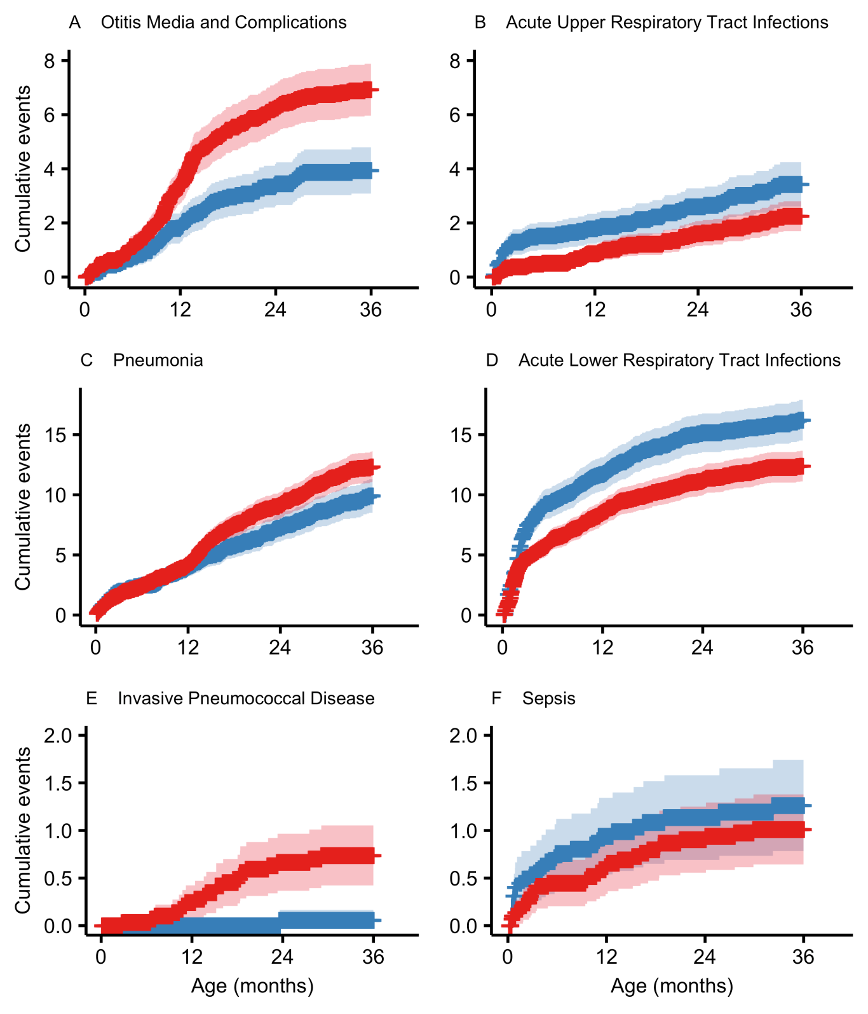

Figure 21 Cumulative incidence of hospitalization per 1,000 children by disease-group

A total of 15 children were admitted to hospital 19 times for meningitis, and 61 children were admitted 63 times for sepsis. The crude incidence rate of meningitis hospitalization was 16.5 and 8.7 per 100,000 person-years in the vaccine non-eligible and vaccine eligible cohorts respectively, and the analogous crude incidence rate for sepsis hospitalizations was 38.8 and 52.3. Culture-confirmed invasive pneumococcal disease was diagnosed in 37 children under three years of age in the study birth-cohorts. Of those, 23 (59%) were admitted for inpatient treatment. Of the admitted children, eight children had a primary discharge diagnosis of Sepsis due to Streptococcus pneumoniae (A40.3), eight were diagnosed with Pneumococcal meningitis (G00.1), two with Pneumonia due to Streptococcus pneumoniae (J13), two with Bacterial pneumonia, not elsewhere classified (J15) and the remaining three were diagnosed with Bacterial meningitis, unspecified (G00.9), Pyogenic arthritis, unspecified (M00.9) and Fever, unspecified (R50.9). The crude incidence of invasive pneumococcal disease, regardless of whether the child was admitted to hospital, was 24.7 per 100,000 person-years in the VNEC compared to 1.74 per 100,000 person-years in the VEC. When only considering hospitalized invasive pneumococcal disease, the crude IR was 24.7 and 1.74 per 100,000 person-years. No vaccine-type invasive pneumococcal disease was diagnosed in the VEC. Crude incidence rates of hospitalization by age-group are shown in Figure 20.

Table 29 Hazard ratios between the vaccine eligible and vaccine non-eligible birth-cohorts for each disease-group

|  |  |
| --- | --- |
| Disease group | Hazard ratio (95%CI) |
| Otitis Media and Complications | 0.56 (0.437-0.73) |
| Acute upper respiratory infection | 1.55 (1.103-2.18) |
| Pneumonia | 0.80 (0.671-0.95) |
| Acute Lower Respiratory Tract Infections | 1.32 (1.137-1.53) |
| Sepsis | 1.26 (0.744-2.12) |
| Invasive Pneumococcal Disease | 0.07 (0.009-0.50) |

The mean age of children admitted for meningitis, sepsis and invasive pneumococcal disease was 9.7 months, 8.4 months and 14.4 months respectively. The cumulative incidence rates of hospitalization per 1000 person-years for sepsis and invasive pneumococcal disease are depicted in Figure 21. The hazard ratio of hospitalization for meningitis between the vaccine eligible and non-eligible cohorts was 0.45 (95%CI 0.15-1.41). An E-value was not computed as the hazard ratio was not significant. The hazard ratio for hospital admissions due to invasive pneumococcal disease between the vaccine eligible and vaccine non-eligible cohorts was 0.07 (95%CI:0.01-0.50), with an E-value of 28.06. and a lower bound of 3.41. The hazard ratio of a sepsis hospitalization between the vaccine eligibility and vaccine non-eligible cohorts was 1.26 (95%CI:0.75-2.13). No E-value was calculated as the ratio was not significant. Restricted analyses in these three diagnostic groups did not alter results significantly.